**Cuts Clothing**

Nilesh Shrestha

B.Sc. (Hons.) Computing, Softwarica College of IT and E-Commerce, Coventry University

ST5007CEM Web Development

Hari Saran Shrestha

February 28, 2024

**Contents**

Introduction 6

Aim 8

Objectives 9

Features 10

Scope of CUTS Clothing 12

Functional Requirement 13

Non-Functional Requirements 18

Individual Reflection 20

Tools and Technologies used 22

Figure 1: Tools and Technologies 22

Conceptual Diagram 26

Figure 2: Entity Relation Diagram 26

Use case Diagram 27

Figure 3: Use case diagram 27

System Architecture 28

Figure 4: Three Tier Architecture 28

Learning Outcomes 29

Frontend 29

Figure 5: Home Page 30

Figure 6: Sign in page 30

Figure 7: Sign up page 31

Figure 8: Clothes page 31

Figure 9: Clothes Detail page 32

Figure 10: Clothes page for men 32

Figure 11: Clothes page for women 33

Figure 12: Filtered Clothes 33

Figure 13: Cart Page 34

Figure 14: Customer Order History Page 34

Figure 15: Dashboard 35

Figure 16: Dashboard Clothes page 35

Figure 17: Add Clothes 36

Figure 18: Edit Clothes 36

Figure 19: Dashboard Order Page 37

Figure 20: Forgot Password Page 37

Figure 21: Reset Password Page 38

Backend 38

Figure 22: Email Config 39

Figure 23: Security Config 40

Figure 24: Authentication Controller 40

Figure 25: Cart Controller 41

Figure 26: Clothing Controller 41

Figure 27: Order Controller 42

Figure 28: User Controller 42

Figure 29: Verification Controller 43

Figure 30: Cart Entity 43

Figure 31: Order Entity 44

Figure 32: Clothes Entity 44

Figure 33: User Entity 45

Figure 34: Cart Repository 45

Figure 35: Clothes Repository 46

Figure 36: Order Repository 46

Figure 37: User Repository 47

Figure 38: Authentication Service 47

Figure 39: Cart Service 48

Figure 40: Clothes Service 48

Figure 41: Email Service 49

Figure 42: JWT Service 49

Figure 43: Order Service 50

Figure 44: User Service 50

Responsive Design 51

Figure 45: Responsive Home Page 52

Testing 53

Unit Testing approach: 53

Figure 46: Backend application Test 54

Figure 47: Cart Controller Test 55

Figure 48: User Controller Test 55

Behavior Driven Development: 56

Conclusion 57

References 58

Appendix 60

GitHub Link: 60

YouTube Link: 60

# Introduction

In the contemporary landscape of online fashion retail, Cuts Clothing emerges as a distinctive player, skillfully intertwining elegance with modern technology. This analysis seeks to explore the inner workings of Cuts Clothing's shopping experience, shaped by the integration of technologies such as React, Spring Boot, and PostgreSQL, with the aim of redefining the norms of the digital fashion sphere.

At the heart of Cuts Clothing lies a dedication to harmonizing comfort with style. The React-powered frontend boasts a contemporary design, ensuring a seamless interface across diverse devices. The navigation through curated collections prioritizes user-friendliness, emphasizing simplicity in the user experience.

A noteworthy aspect of Cuts Clothing's platform is the personalized shopping experience facilitated through user accounts. Users can tailor their journey, engage in secure checkout processes, and experience efficient order management, all orchestrated by the dependable Spring Boot backend. The interactive virtual fitting room feature enhances the visual dimension, allowing users to preview selected items before making final decisions.

Cuts Clothing extends beyond transactional exchanges, fostering a virtual community for fashion enthusiasts through forums and social media engagement. This community interaction promotes the exchange of style insights, participation in discussions, and staying informed about emerging trends.

The seamless integration of elegance and innovation is evident through streamlined returns and exclusive promotions. Although lacking in email notifications, Cuts Clothing remains a dynamic force reshaping the essence of online fashion. Each element within this virtual space tells a unique story, and the blend of elegance and technology sets the stage for an immersive and transformative shopping experience. This discussion invites readers to reflect on the evolving narrative of style within the realm of Cuts Clothing.

# Aim

Cuts Clothing is dedicated to reshaping the online fashion experience, aspiring to provide users with a seamless and user-friendly interface that connects them to a rich tapestry of diverse styles and designs. Our aim is to elevate the shopping journey by offering a personalized exploration through various fashion genres. Beyond being a digital storefront, we strive to foster an engaged and vibrant community of fashion enthusiasts through interactive forums and social media. At the heart of our mission is the commitment to transform the act of online shopping into an enjoyable and communal exploration of individual style preferences.

# Objectives

Objectives for CUTS Clothing website development are as follows:

* Conduct a comprehensive analysis of website requirements, emphasizing functionality, user experience, security, and scalability for the development of the Cuts Clothing website.
* Develop clear and visual representations of system interactions and processes through the creation of use case, activity, and sequence diagrams, fostering a deep understanding of web development concepts.
* Leverage the power of React, Spring Boot, and PostgreSQL to craft a sophisticated, responsive, and user-friendly website for Cuts Clothing, simultaneously gaining hands-on experience and proficiency in cutting-edge technologies.
* Design and implement a streamlined navigation system for the Cuts Clothing website, ensuring an intuitive and seamless user experience.
* Utilize PostgreSQL as the primary database for efficient data storage, retrieval, and management, safeguarding user data and maintaining system integrity for the Cuts Clothing website, and acquiring a nuanced understanding of website security measures.
* Explore and implement advanced techniques to continuously improve web development skills, embracing a growth mindset and staying informed about industry advancements, demonstrating commitment to ongoing learning and adaptability.
* Demonstrate autonomy and individual responsibility in the solo development of the Cuts Clothing website, showcasing the ability to self-manage tasks, troubleshoot challenges, and deliver a fully functional and polished website.

# Features

Features of this website are as follows:

1. **User Registration**

Allow users to create personalized accounts, providing a gateway to a tailored shopping experience on the Cuts Clothing website.

1. **User Authentication**

Ensure a secure login process with unique credentials, offering authorized access to personalized features and account information.

1. **Secure Password Management**

Implement advanced security measures to protect user passwords through secure hashing techniques, enhancing overall account security.

1. **Forgot Password Functionality**

Provide users with a secure and user-friendly process to reset passwords through email verification, ensuring easy account recovery.

1. **Role-Based Authorization System with Admin Panel**

Establish a structured role-based authorization system differentiating user types, empowering administrators with an efficient panel to manage accounts, products, and content.

1. **Responsive Design**

Create a visually appealing and user-friendly interface that seamlessly adapts to various devices, offering a consistent experience across desktops, tablets, and smartphones.

1. **Product Catalog**

Showcase a diverse range of clothing items with high-quality images and detailed descriptions, facilitating easy exploration and informed purchasing decisions.

1. **Secure Checkout Process**

Ensure a secure and streamlined checkout process with multiple payment options, providing users with a transparent and trustworthy transaction experience.

1. **Search Functionality**

Enable users to quickly find specific items or styles through a robust search feature, enhancing the overall accessibility of the product catalog

1. **Secure Session Management**

Implement secure session management techniques to authenticate and authorize users throughout their visit, safeguarding user data and ensuring a protected browsing experience.

1. **Shipping**

Facilitate a seamless and reliable shipping service for purchased items, ensuring swift and secure delivery to enhance the overall customer experience on the Cuts Clothing website.

# Scope of CUTS Clothing

The Cuts Clothing website project aims to create a cutting-edge online fashion retail platform that seamlessly integrates user-friendly features and advanced technologies. The primary objective is to provide users with a secure, responsive, and personalized shopping experience. The website will feature a comprehensive product catalog, user registration, secure authentication, and a role-based authorization system with an intuitive administrator panel. Additionally, the scope includes implementing secure checkout processes, efficient search functionality, secure session management, and reliable shipping services. The successful delivery of this project will result in a fully functional, aesthetically pleasing, and secure platform that caters to the diverse needs of fashion enthusiasts while adhering to the project timeline and budget constraints.

# Functional Requirement

Functional requirements for CUTS Clothing are as follows:

* **User Registration**

|  |  |
| --- | --- |
| **Use Case Name** | **User Registration** |
| **Precondition** | **None** |
| **Basic Path** | 1. User navigates to the registration page.  2. User enters their credentials.  3. System validates information.  4. If valid, the account is created, and details are stored securely.  5. User receives confirmation and is redirected to login. |

* **User Login**

|  |  |
| --- | --- |
| **Use Case Name** | **User Login** |
| **Precondition** | **User has an account** |
| **Basic Path** | 1. User visits the login page. 2. User enters their credentials. 3. System authenticates the user. 4. User gains access to the platform (dashboard) for admin. |

* **Comprehensive Product Catalog**

|  |  |
| --- | --- |
| **Use Case Name** | **Product Catalog Management** |
| **Precondition** | **System has clothes** |
| **Basic Path** | 1. User navigates to the catalog section. 2. System displays a comprehensive catalog. 3. User interacts to add, update, or remove products. |

* **Detailed Clothing Information**

|  |  |
| --- | --- |
| **Use Case Name** | **Clothes Details Retrieval** |
| **Precondition** | **Clothes are available** |
| **Basic Path** | 1. User selects a clothing item. 2. System retrieves and displays detailed information including descriptions, price, colors and sizes. |

* **Efficient Search and Filtering**

|  |  |
| --- | --- |
| **Use Case Name** | **Search and Filter Clothes** |
| **Precondition** | **Catalog has searchable items** |
| **Basic Path** | 1. User utilizes the search bar or filtering options.  2. System performs search or filter based on user criteria.  3. System displays refined results. |

* **Online Purchasing**

|  |  |
| --- | --- |
| **Use Case Name** | **Secure Checkout** |
| **Precondition** | **User has items in cart** |
| **Basic Path** | 1. User adds items to the cart.  2. User proceeds to checkout.  3. System securely processes the payment.  4. User receives confirmation of the purchase. |

* **Home Delivery Service**

|  |  |
| --- | --- |
| **Use Case Name** | **Delivery Address Input** |
| **Precondition** | **User has completed Purchase** |
| **Basic Path** | 1. User provides delivery address during checkout.  2. System stores the delivery address for home delivery services. |

* **Responsive Design**

|  |  |
| --- | --- |
| **Use Case Name** | **Cross-Device Optimazation** |
| **Precondition** | **None** |
| **Basic Path** | 1. User accesses the platform from various devices. 2. System optimizes the layout, images, and functionalities based on the device's screen size |

* **Latest and Bestselling releases and recommendation**

|  |  |
| --- | --- |
| **Use Case Name** | **Personalized Suggestion** |
| **Precondition** | **User History is available** |
|  | 1. System analyzes user behavior and preferences.  2. System provides information on the latest releases.  3. System offers personalized clothing recommendations. |

* **Secure Payment Option**

|  |  |
| --- | --- |
| **Use Case Name** | **Payment Processing** |
| **Precondition** | **User initiates payment** |
| **Basic Path** | 1. User selects preferred payment option. 2. System securely processes the payment using the chosen method. |

* **Order Tracking**

|  |  |
| --- | --- |
| **Use Case Name** | **Order Status Monitoring** |
| **Precondition** | **User has placed an order** |
| **Basic Path** | 1. User navigates to the order tracking section.  2. System displays real-time status updates for the user's order. |

# Non-Functional Requirements

Non-functional requirements specify constraints and expectations for clothing store’s performance, security, usability, scalability and reliability, ensuring an effective and user-friendly experience. (Editor, 2020).

**Usability:**

The online bookstore must feature a user-friendly interface, allowing easy navigation and streamlined book selection and purchase processes.

**Security:**

Robust security measures are essential to safeguard user data from unauthorized access, breaches, and potential threats. (CrowdStrike, 2023).

**Scalability**:

The platform should seamlessly handle increasing users, books, and transactions without compromising performance to ensures responsiveness with a growing user base.

**Data Persistence:**

Implementing data persistence is crucial, securely storing user interactions, book details, and purchase history for continued usability and personalization. (Pfeil, 2010).

**Reliability:**

Users should experience uninterrupted access with minimal downtime. Redundant servers, backup systems, and safeguards against data loss contribute to a reliable platform.

**Performance**:

The online bookstore must ensure fast response times for users to browse and purchase books efficiently. This requires robust server infrastructure, optimized database architecture, and performance-enhancing measures.

# Individual Reflection

Embarking on the exploration of Cuts Clothing, an enticing online fashion sanctuary, has been a transformative journey that seamlessly integrates technology with the nuances of personal style. As an undergraduate student, navigating the digital atelier of Cuts Clothing has provided profound insights into the catalytic role of web development in reshaping the dynamic landscape of the fashion industry. The secure and exclusive nature of the website not only reflects the evolving language of fashion but also mirrors my personal growth, symbolizing a student's embrace of the intersection between technology and creative expression.

Viewing Cuts Clothing through the lens of a fervent fashion enthusiast, the platform unfolded as a dynamic canvas of styles, each click through the meticulously curated product catalog akin to entering a digital wardrobe. The intuitive design, complemented by detailed descriptions and high-resolution visuals, facilitated a seamless exploration, transforming the selection of garments into a virtual shopping spree. This interactive platform provided a firsthand encounter with the transformative potential of technology in curating a personalized and engaging digital space for fashion enthusiasts.

Transitioning into the administrator's role unveiled a distinct perspective—an esteemed position within the digital atelier where decisions reverberate across the unfolding narrative of fashion on the platform. The dashboard became my realm for creative stewardship, enabling the introduction of new styles, refinement of collections, and real-time synchronization of changes with the user interface. This duality of roles not only broadened my understanding of the symbiotic relationship between user experience and behind-the-scenes administration but also revealed the intricate dance of technology and design shaping the platform's identity.

Cuts Clothing's unwavering commitment to user-friendly design and dynamic interaction served as a canvas for me to delve into the fusion of technology and fashion. The platform's flexibility, allowing me to update my profile and personalize my digital presence, enriched the immersive and engaging nature of the online fashion experience. In this exploration, Cuts Clothing transcended its identity beyond a mere digital storefront, evolving into a living experiment situated at the crossroads of technology and personal expression.

As student, this journey symbolizes a profound voyage of self-discovery, unveiling the potential of digital platforms to shape individual narratives and leaving an indelible mark on my evolving understanding of the dynamic interplay between technology and personal style. From a broader perspective, this experience has fueled my curiosity and passion for the continuous evolution of the digital fashion landscape, propelling me towards further exploration and learning in the realm of web development and creative expression.

# Tools and Technologies used

### Figure 1: Tools and Technologies

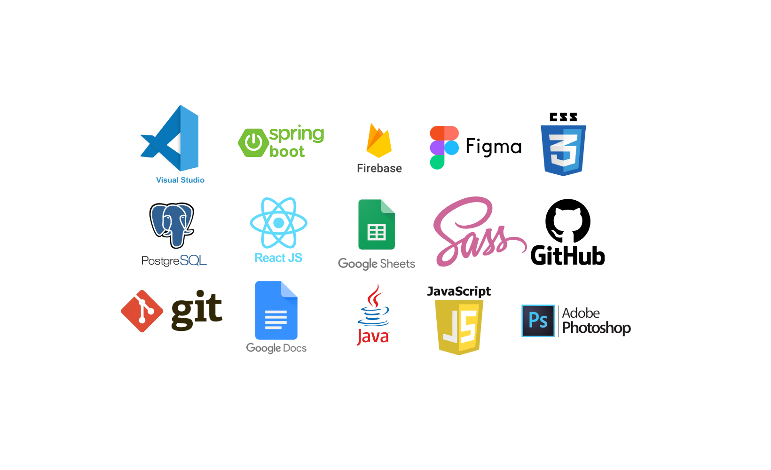

1. **Figma**

Figma is a cloud-based design and prototyping tool used in web and interface design. It is popular among designers and teams for its collaborative features and the ability to work in real-time. Figma allows users to create, share, and collaborate on design prototypes, wireframes, and user interfaces.

1. **React**

React, or React.js, is an open-source JavaScript library for building user interfaces or UI components, particularly for single-page applications where the user interacts with the application without needing to refresh the entire page. Developed and maintained by Facebook, React provides a declarative, efficient, and flexible way to build UI components for web applications. (Deshpande, 2023).

1. **CSS, SASS and SCSS**

CSS (Cascading Style Sheets), SASS (Syntactically Awesome Stylesheets), and SCSS (Sassy CSS) are style sheet languages used for describing the look and formatting of a document written in a markup language. (Admin, 2022)

1. **JavaScript**

JavaScript is a high-level, versatile programming language primarily used for building dynamic and interactive web pages. It is executed on the client-side by web browsers, enabling the creation of responsive and engaging user experiences.

1. **Git and GitHub**

Git is a distributed version control system that tracks changes in source code during software development. GitHub is a web-based platform built on Git, offering centralized hosting and collaborative tools for software projects, such as code hosting, pull requests, and issue tracking.

1. **Java**

Java is a versatile, object-oriented programming language designed for creating platform-independent applications. Known for its portability, security features, and wide usage in web and enterprise development, Java applications run on the Java Virtual Machine (JVM), allowing them to be executed on various devices and operating systems.

1. **Springboot and Hibernate**

Spring Boot is a streamlined framework built atop Spring, designed to simplify the development of production-ready Spring applications by providing conventions and defaults. It reduces boilerplate code and facilitates rapid application setup and deployment (Kalam, 2023). Hibernate, on the other hand, is a robust Java-based ORM framework that streamlines database interactions by enabling developers to work with Java objects rather than direct SQL queries (Abba, 2022).  When integrated with Spring Boot, Hibernate becomes an integral part of managing the persistence layer, enhancing the efficiency and simplicity of database operations in Java applications.

1. **PostgreSQL**

PostgreSQL is a powerful, open-source relational database management system (RDBMS) known for its advanced features, extensibility, and support for complex data types. It provides strong ACID compliance, scalability, and a rich set of functionalities, making it a popular choice for various applications, from small projects to large-scale enterprise solutions.

1. **Firebase**

Firebase is a versatile mobile and web development platform by Google, offering services like real-time databases and cloud storage. Developers leverage Firebase for efficient image storage in projects, utilizing its secure and scalable cloud storage infrastructure to seamlessly handle and retrieve images for applications.

Creating the Cuts Clothing website was a practical learning journey that honed my skills in React for frontend development, Spring Boot, PostgreSQL, and Hibernate for backend processes, and Firebase for streamlined image storage. This project not only improved my proficiency in these tools but also highlighted their collaborative strength in crafting a feature-rich web application.

# Conceptual Diagram

### Figure 2: Entity Relation Diagram

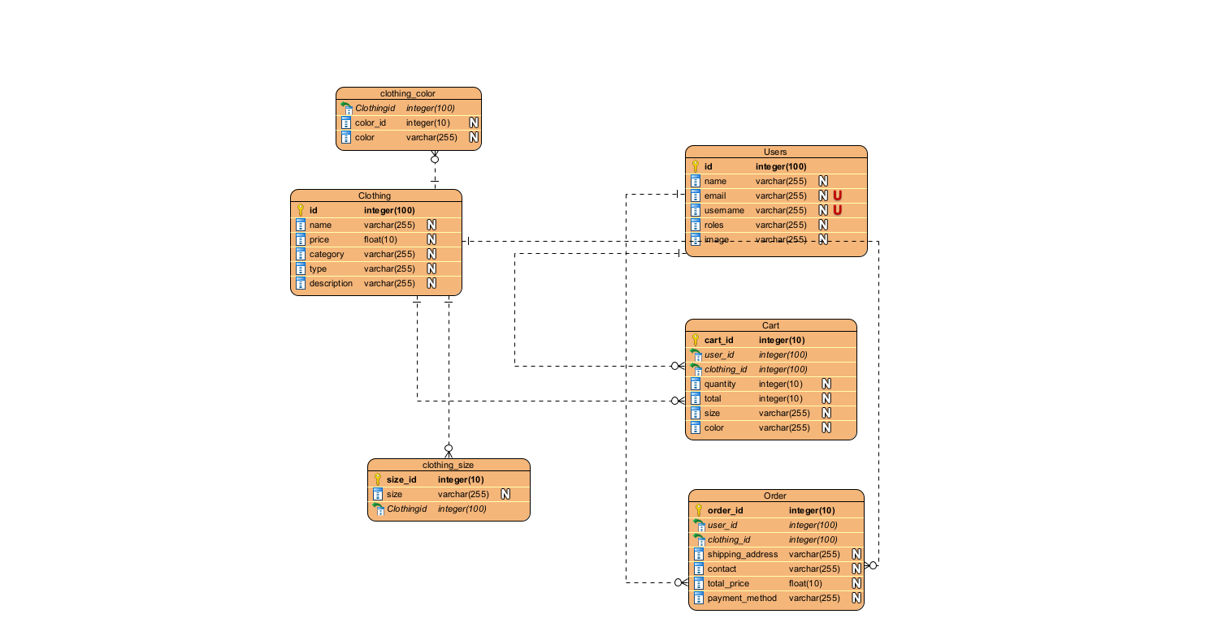

# Use case Diagram

### Figure 3: Use case diagram

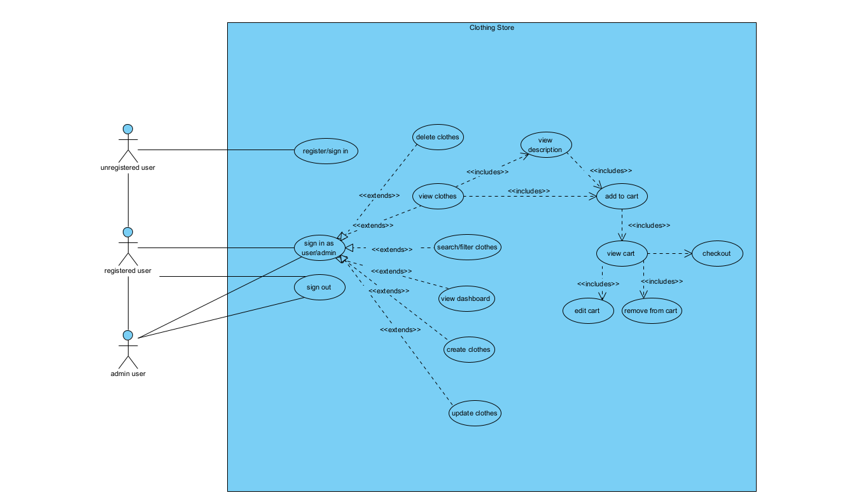

# System Architecture

### Figure 4: Three Tier Architecture

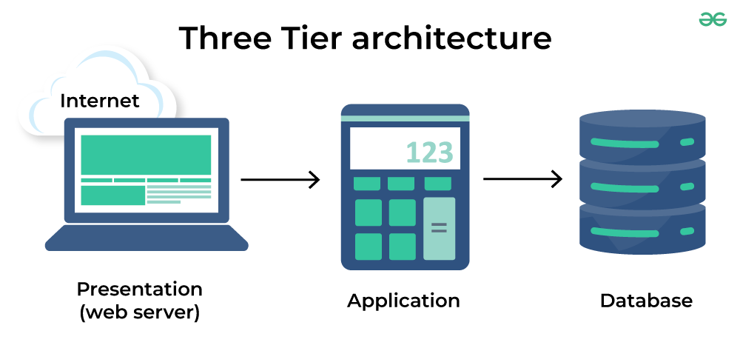

A three-tier system architecture is a software design approach that divides an application into three interconnected layers, each serving a specific purpose. The presentation tier, or user interface layer, handles interactions with users and displays information. The application tier, also known as the business logic layer, manages the application's rules, calculations, and workflows. It acts as an intermediary between the presentation tier and the data tier. The data tier, or storage layer, is responsible for storing and retrieving data from databases. This modular structure enhances modifiability, scalability, and flexibility in development and maintenance, making it a popular choice for web applications where user interfaces, business logic, and data storage are distinct components. (*What Is Three-Tier Architecture | IBM*, n.d.).

# Learning Outcomes

### Frontend

In the realm of frontend development within the Cuts Clothing project, a notable learning outcome was the mastery of React, particularly emphasizing the use of the Context API for global state management. The project offered an immersive experience in understanding and implementing component-based architecture, focusing on creating modular and reusable components. The utilization of the Context API for state management facilitated a centralized approach to handling global application state, streamlining communication between components and enhancing overall maintainability.

Moreover, the exploration of state management extended to leveraging the Context API for handling complex states and avoiding prop drilling. Practical tasks included creating and consuming context providers and consumers, showcasing how this powerful tool can efficiently manage shared state across different parts of the application.

The project also emphasized the integration of third-party libraries and packages within the React ecosystem, aligning with the project's commitment to efficiency and simplicity. This involved incorporating tools for routing, ensuring seamless navigation within the application, and integrating other context providers to manage specific aspects of the global state.

### Figure 5: Home Page

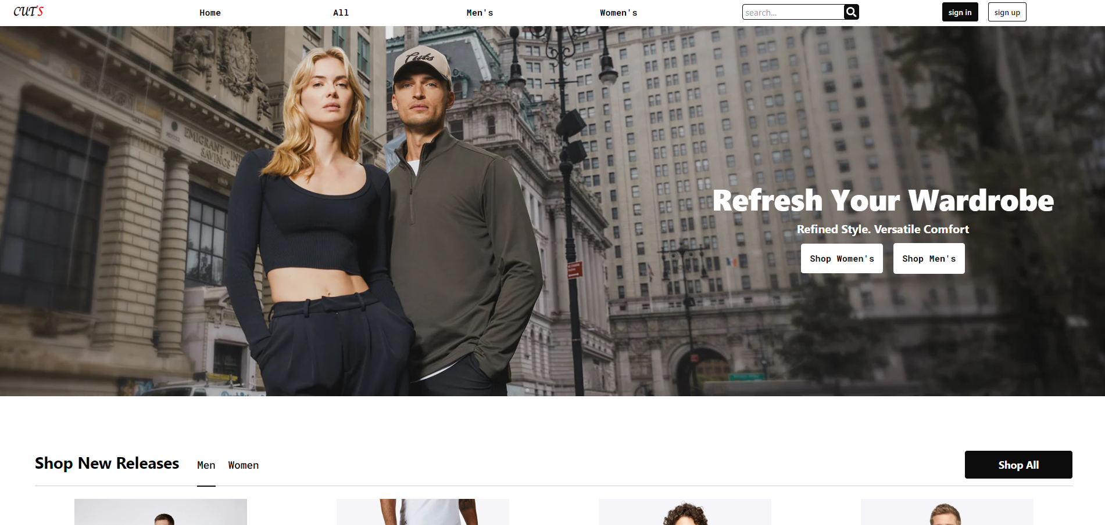

### Figure 6: Sign in page

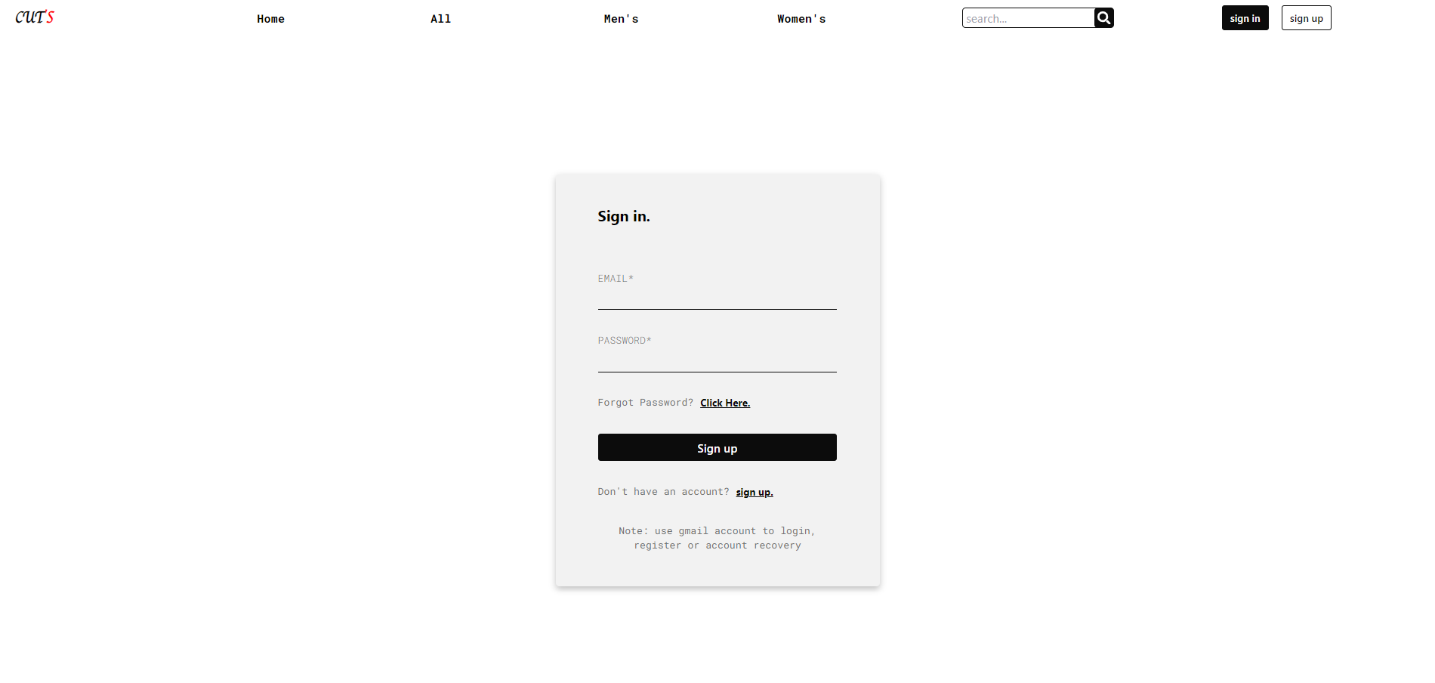

### Figure 7: Sign up page

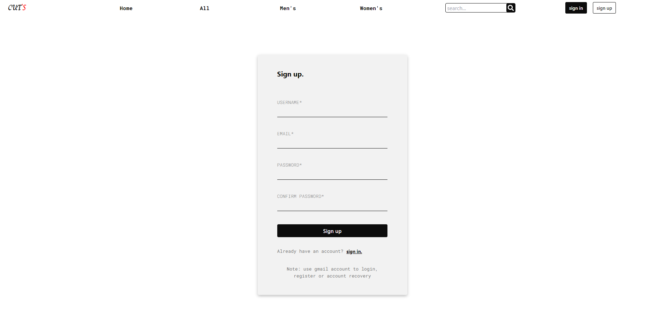

### Figure 8: Clothes page

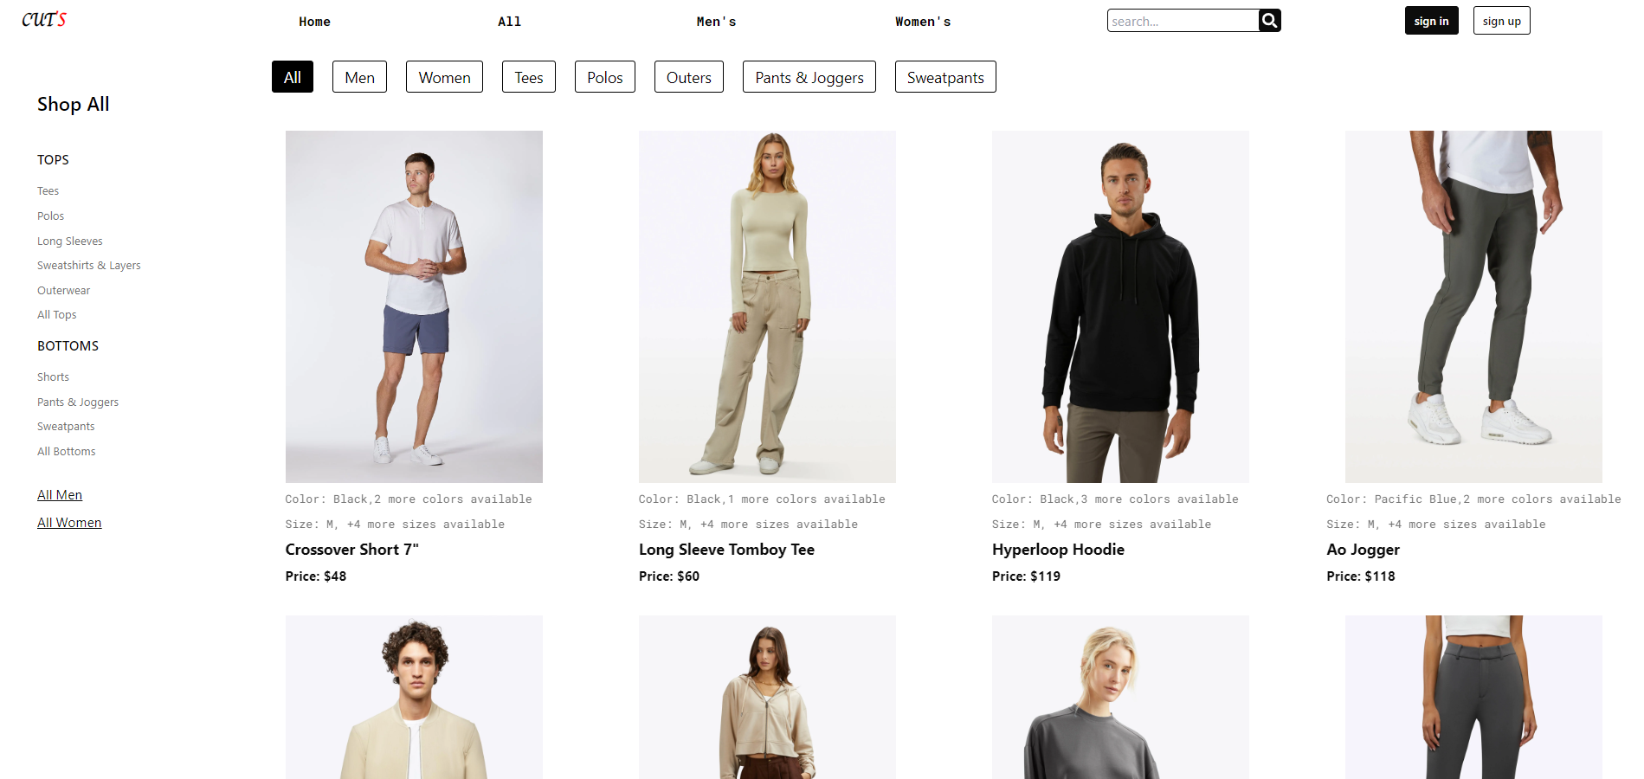

### Figure 9: Clothes Detail page

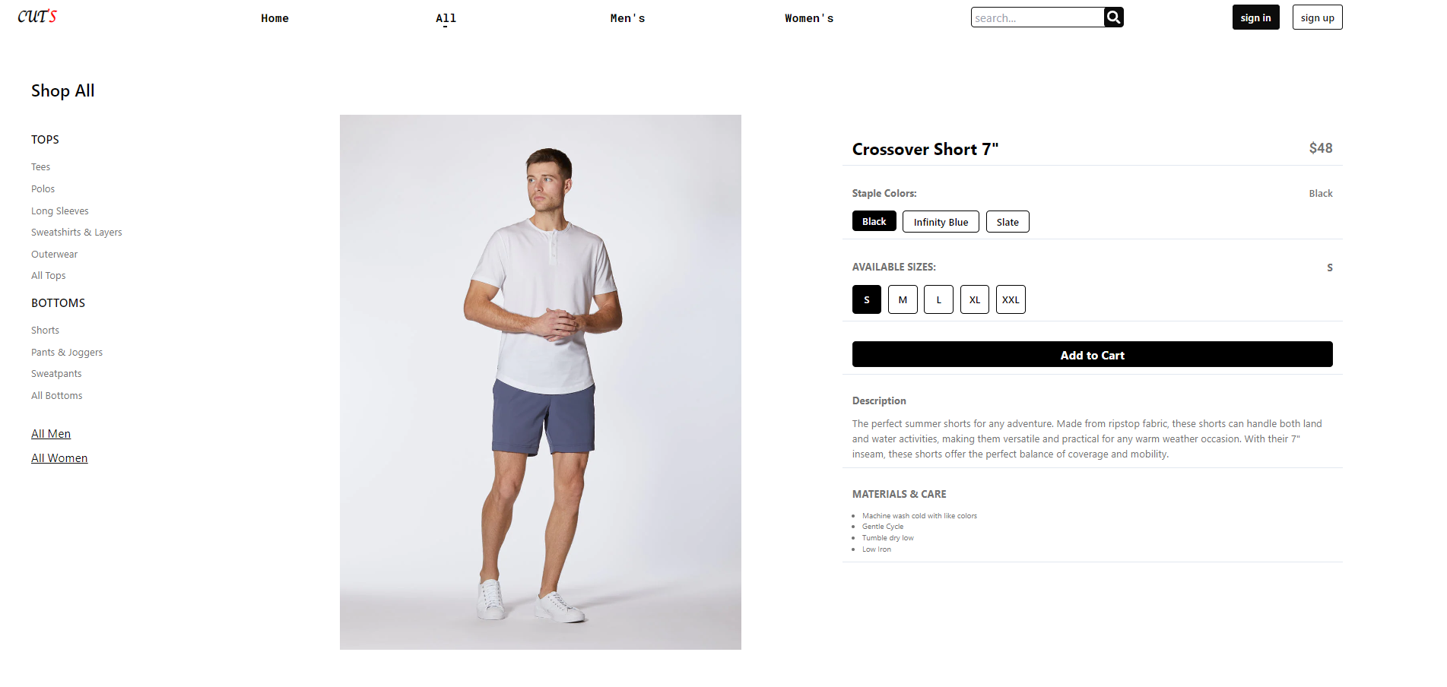

### Figure 10: Clothes page for men

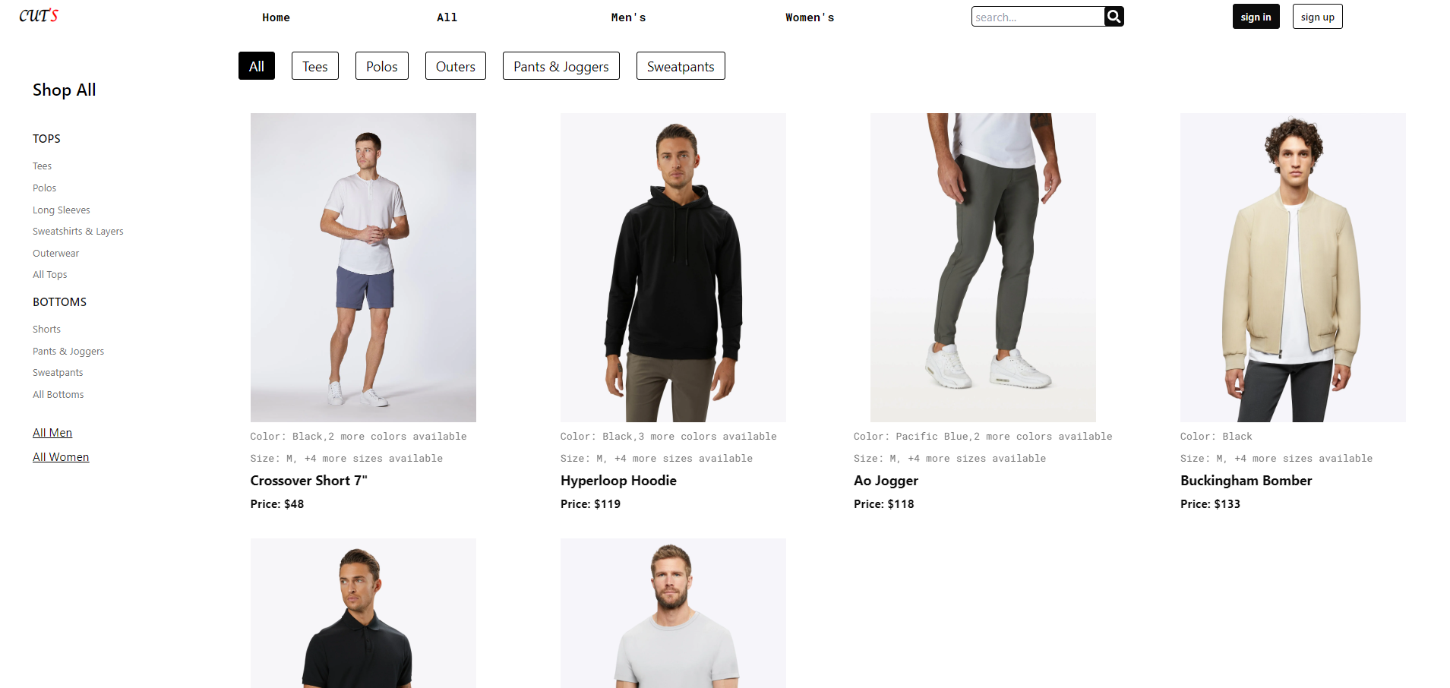

### Figure 11: Clothes page for women

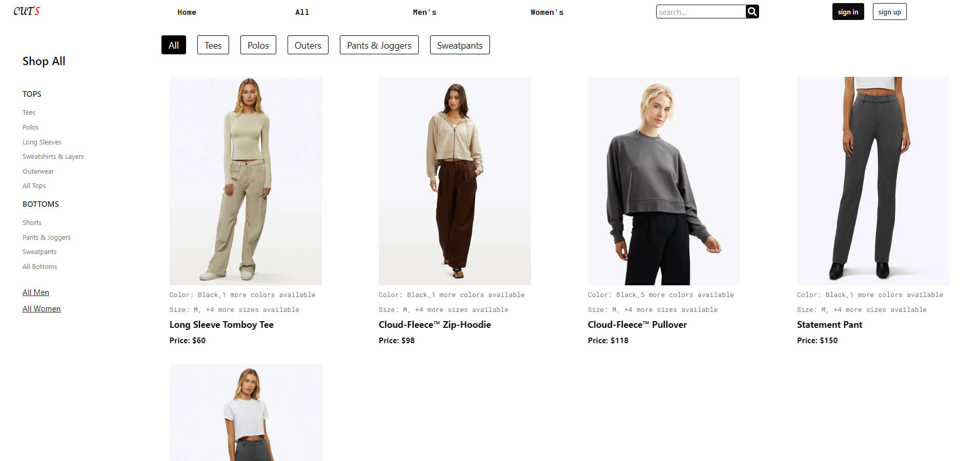

### Figure 12: Filtered Clothes

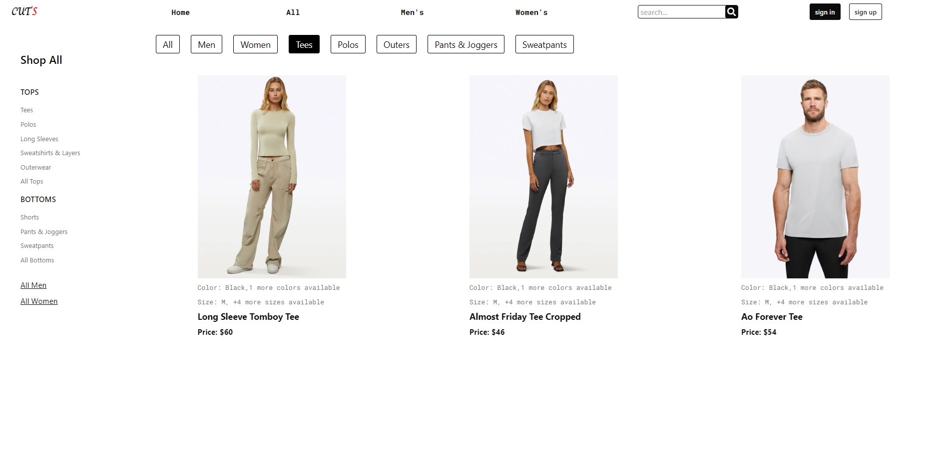

### Figure 13: Cart Page

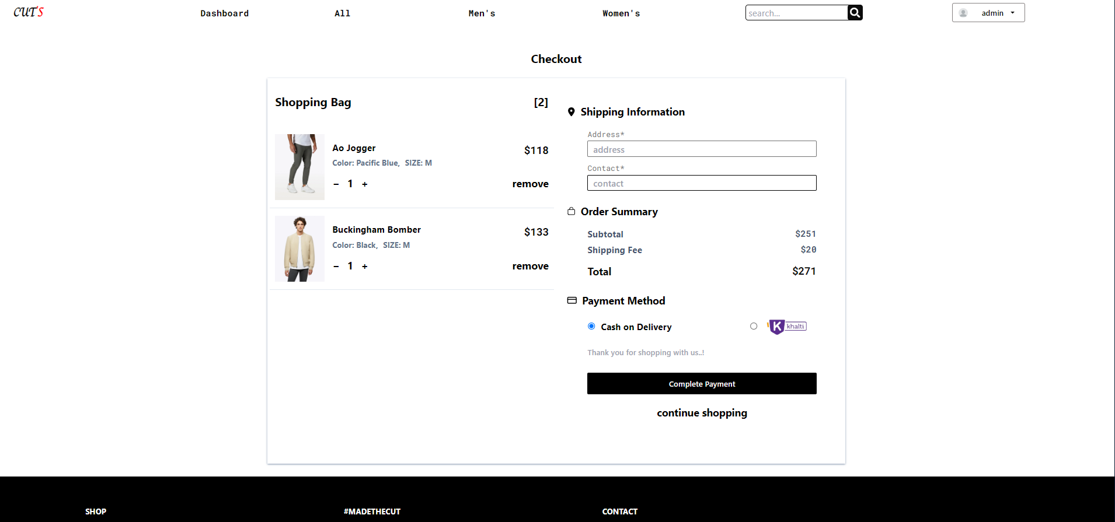

### Figure 14: Customer Order History Page

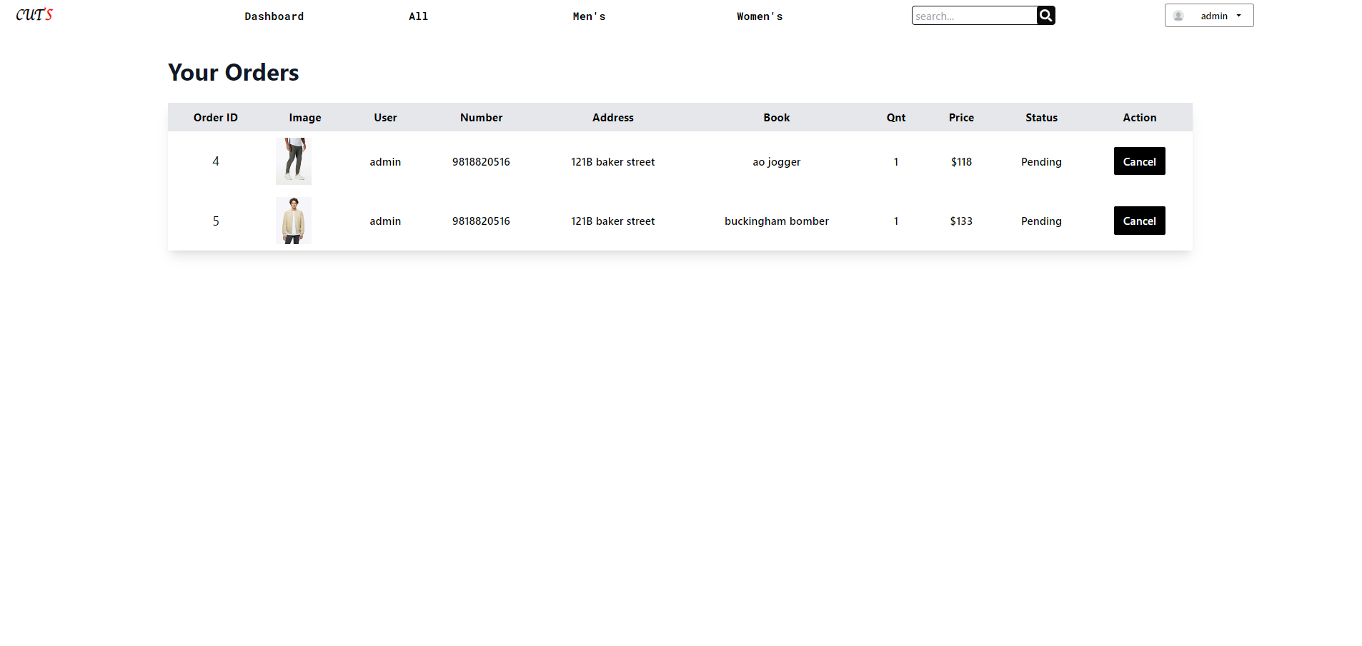

### Figure 15: Dashboard

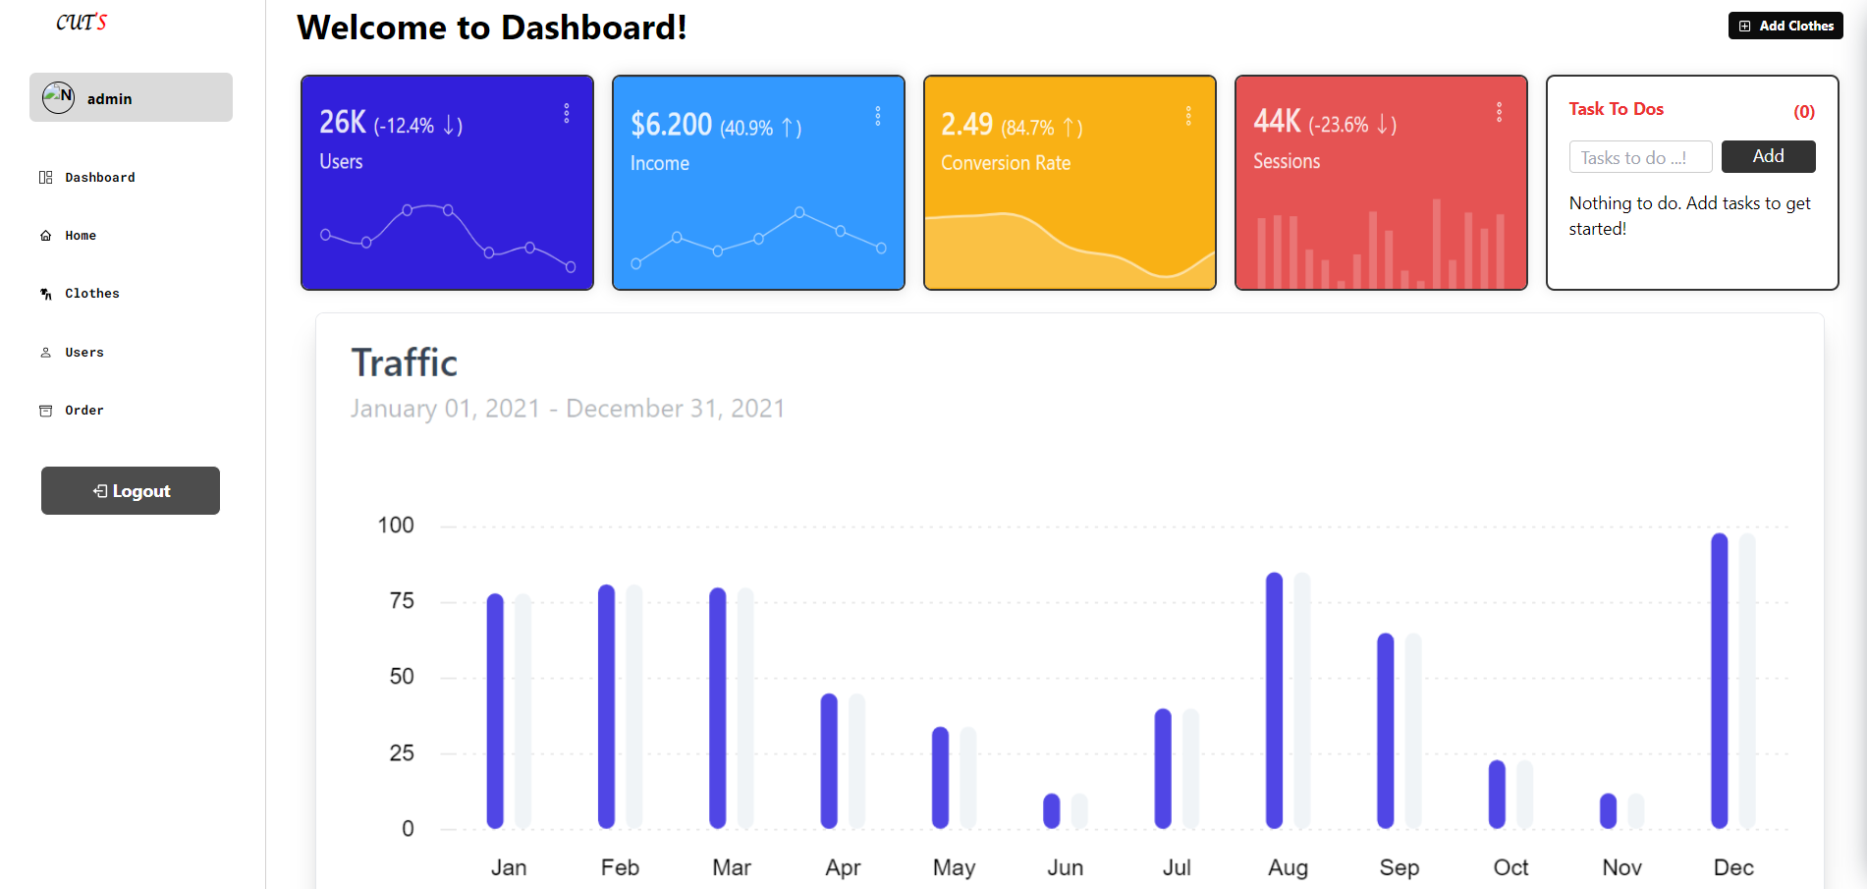

### Figure 16: Dashboard Clothes page

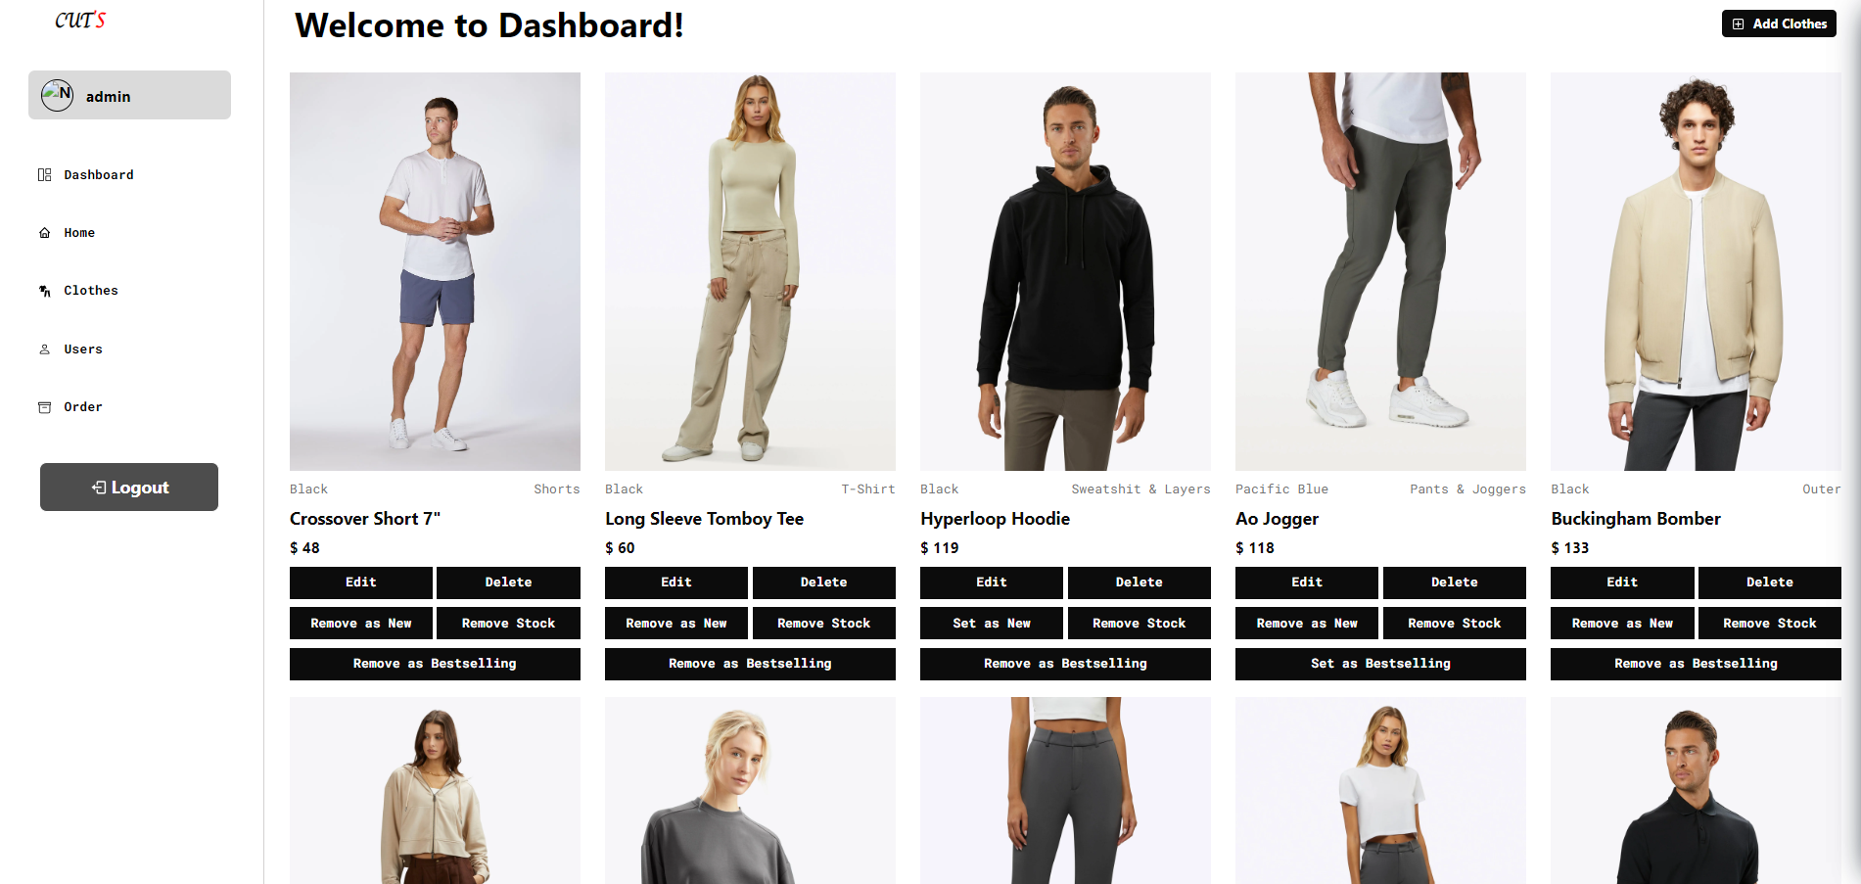

### Figure 17: Add Clothes

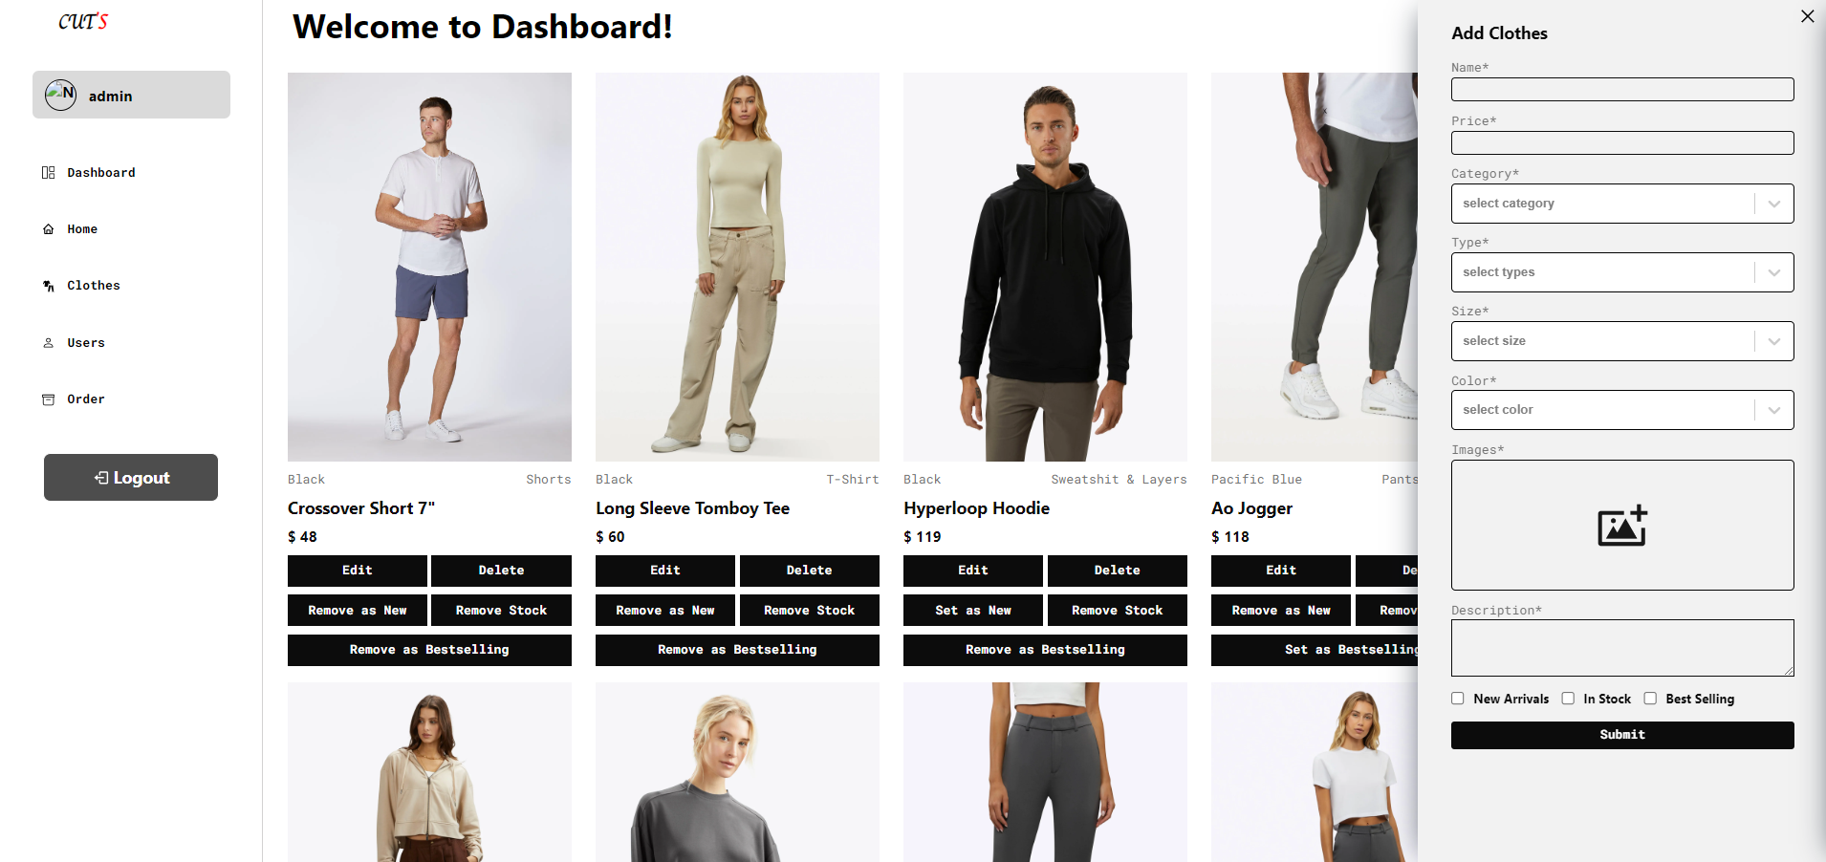

### Figure 18: Edit Clothes

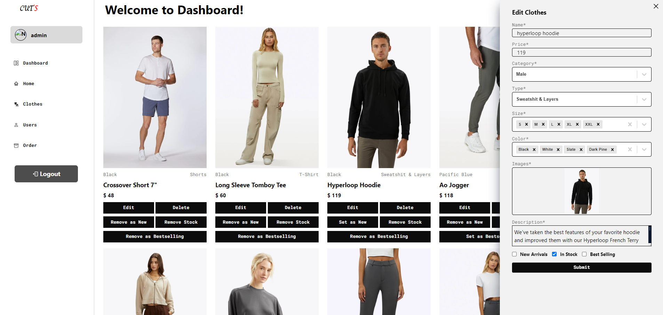

### Figure 19: Dashboard Order Page

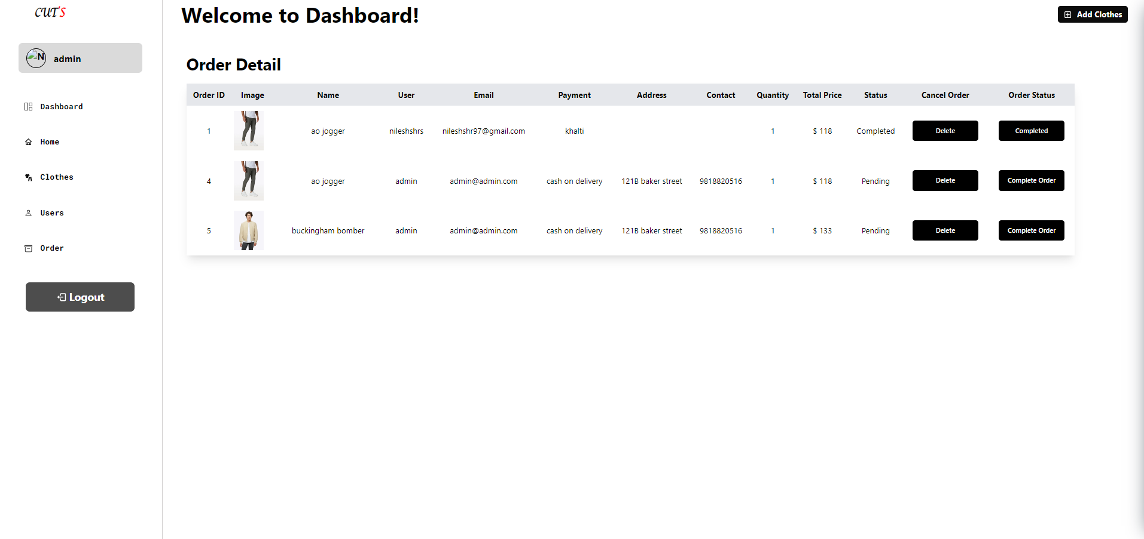

### Figure 20: Forgot Password Page

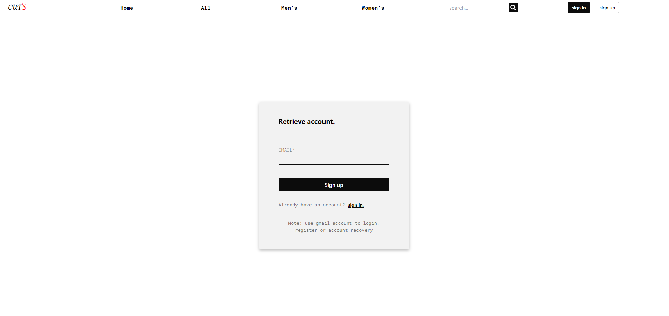

### Figure 21: Reset Password Page

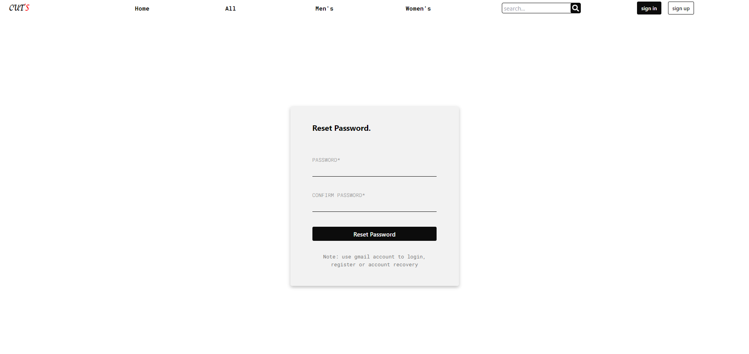

### Backend

Backend development proficiency, particularly with Spring Boot, emerged as a significant learning outcome in the Cuts Clothing project. The exploration of Spring Boot involved understanding and implementing RESTful APIs, showcasing the capacity to design and develop endpoints that seamlessly communicated with the frontend components. This integration between frontend and backend emphasized the importance of a cohesive architecture in web application development.

Database management formed a crucial component of the backend development process. Utilizing PostgreSQL as the relational database and Hibernate as the Object-Relational Mapping (ORM) tool, the project delved into schema design, data modeling, and efficient data retrieval. Understanding how to structure and manage data within a relational database contributed to a robust backend foundation.

The project also exposed the significance of handling security concerns in backend development, including user authentication and authorization. Implementing secure endpoints and managing user access rights became essential skills, enhancing the overall resilience of the web application.

### Figure 22: Email Config

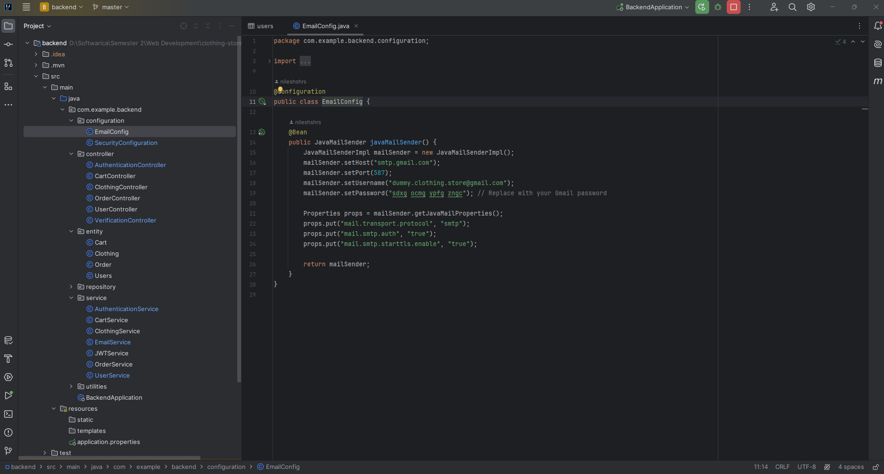

### Figure 23: Security Config

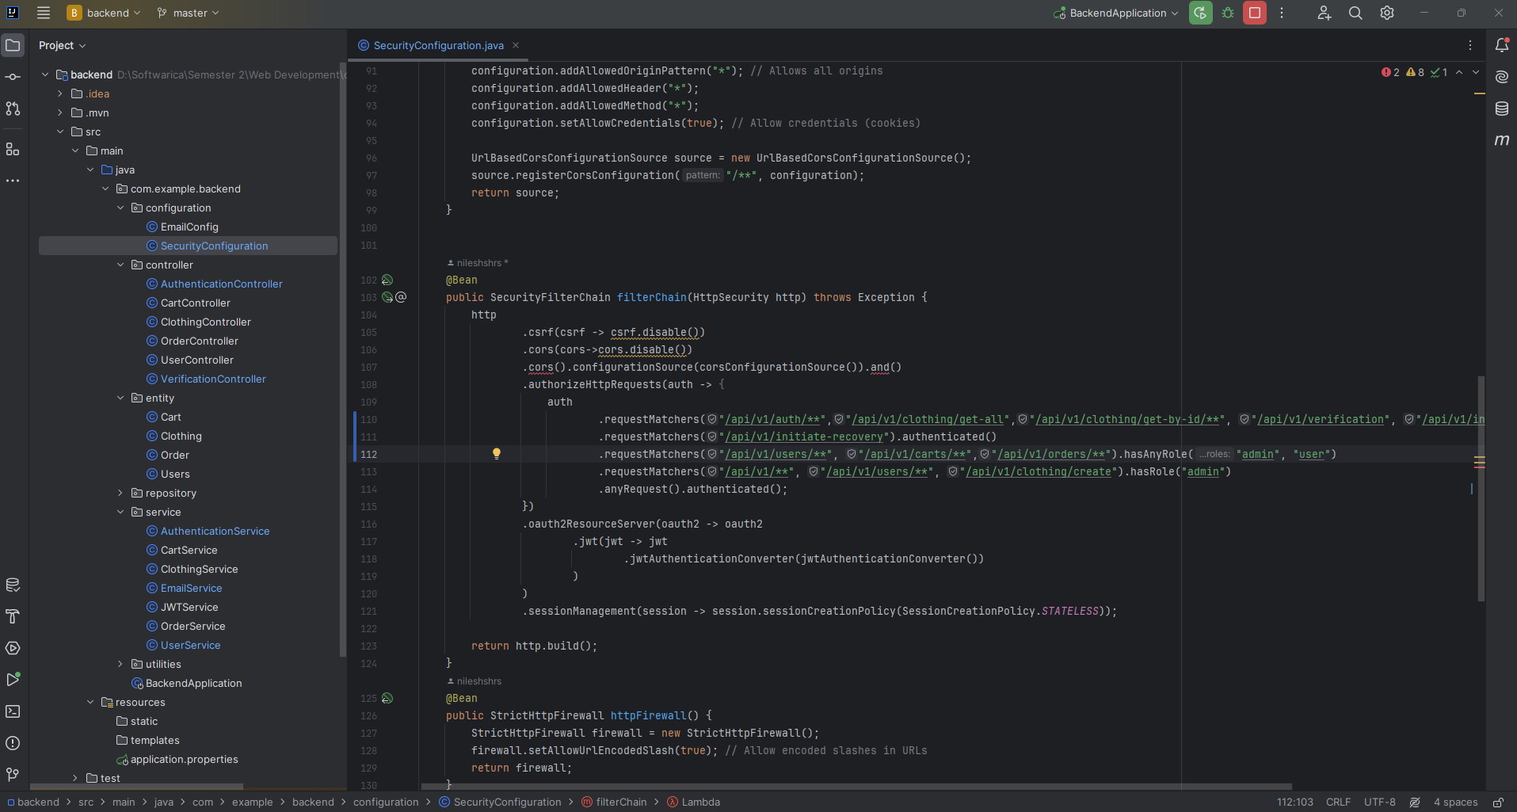

### Figure 24: Authentication Controller

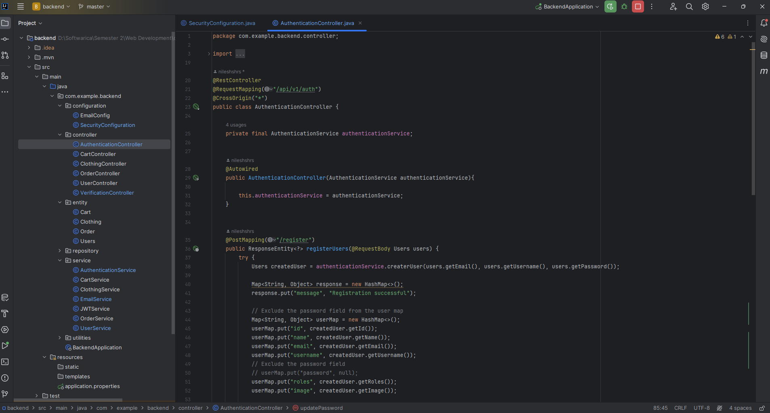

### Figure 25: Cart Controller

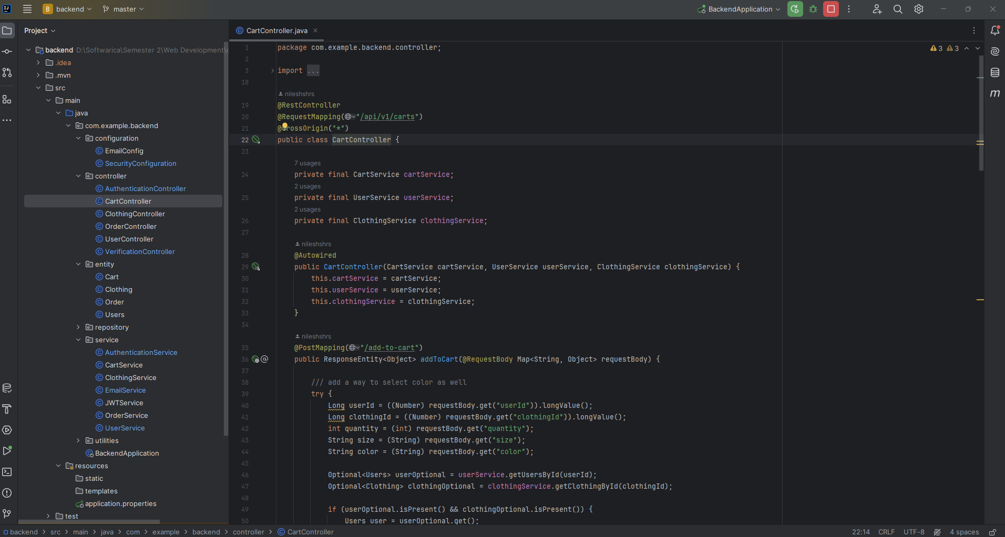

### Figure 26: Clothing Controller

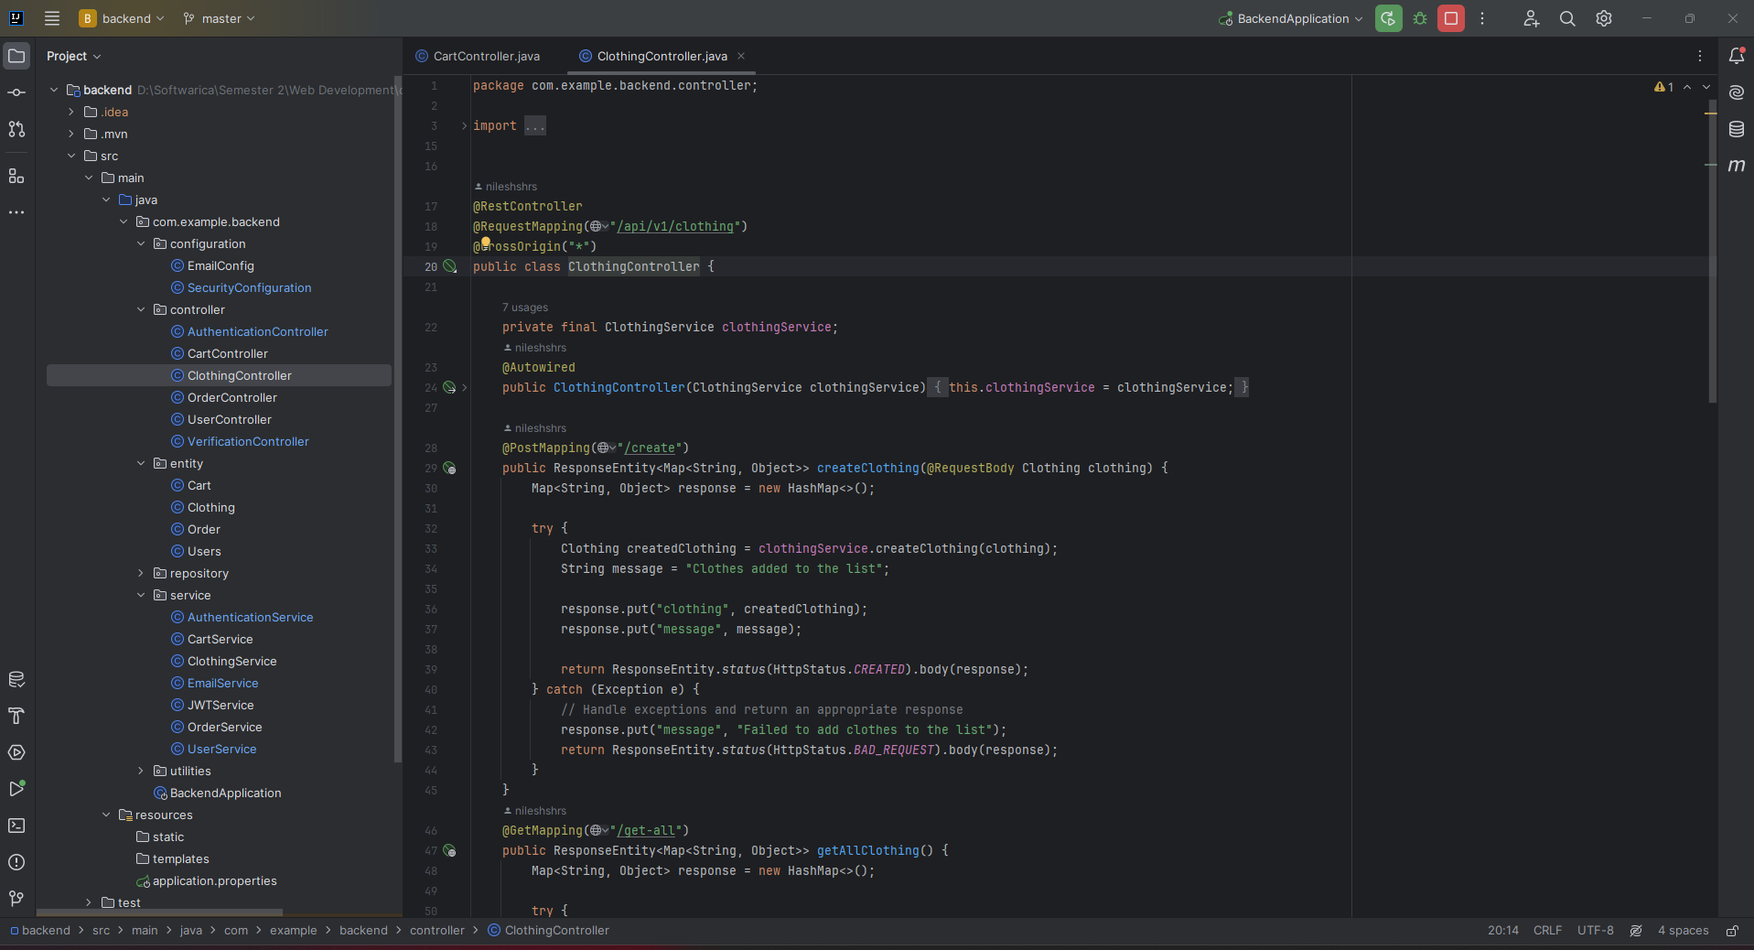

### Figure 27: Order Controller

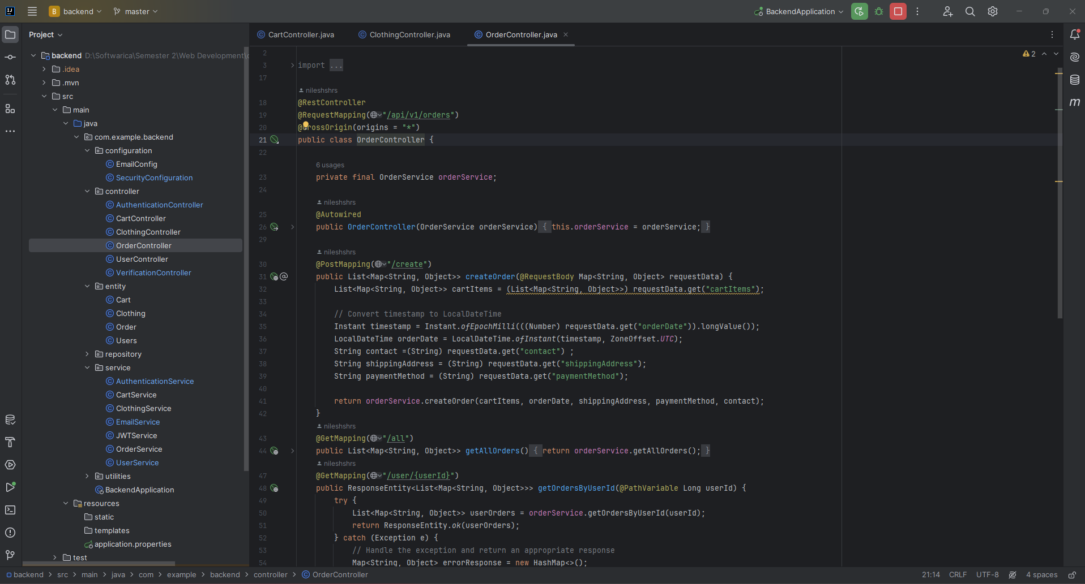

### Figure 28: User Controller

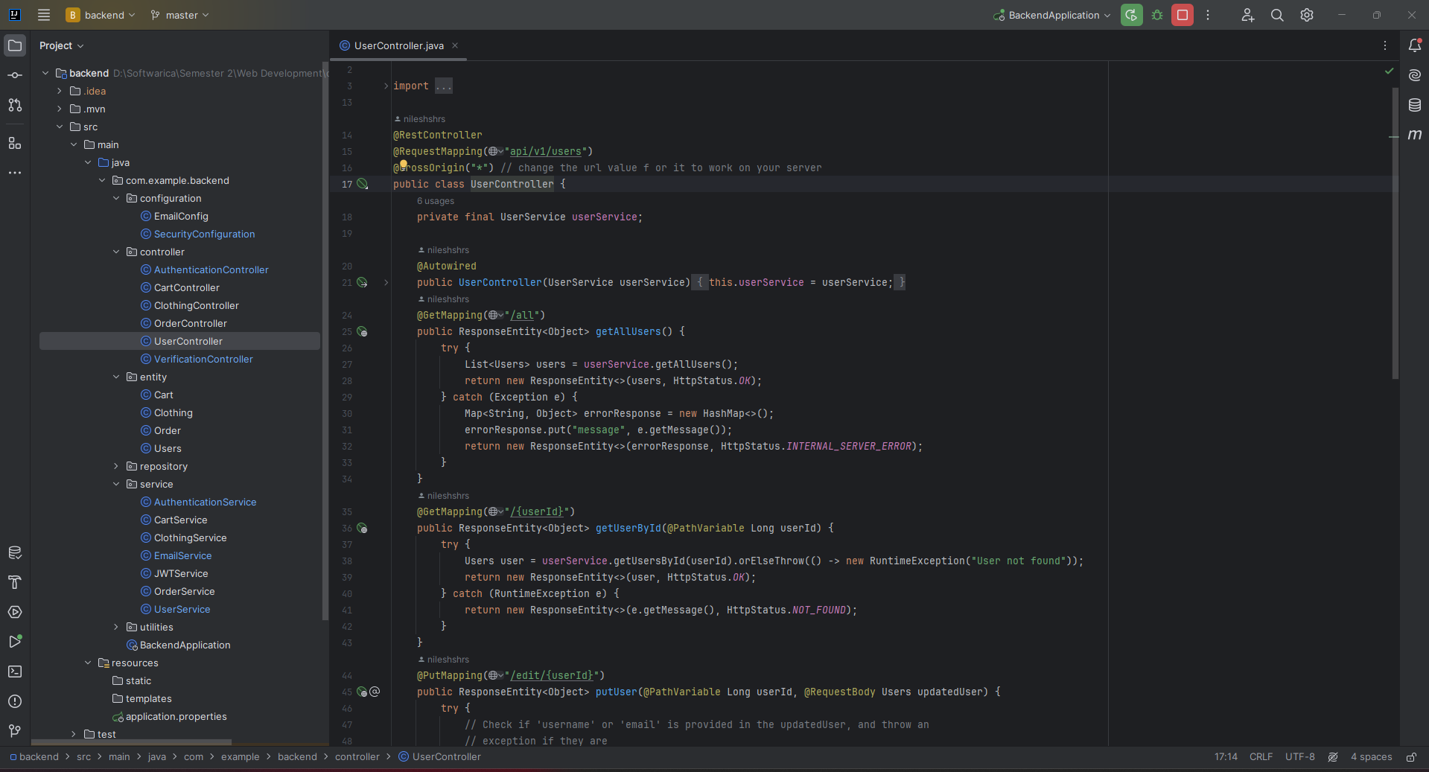

### Figure 29: Verification Controller

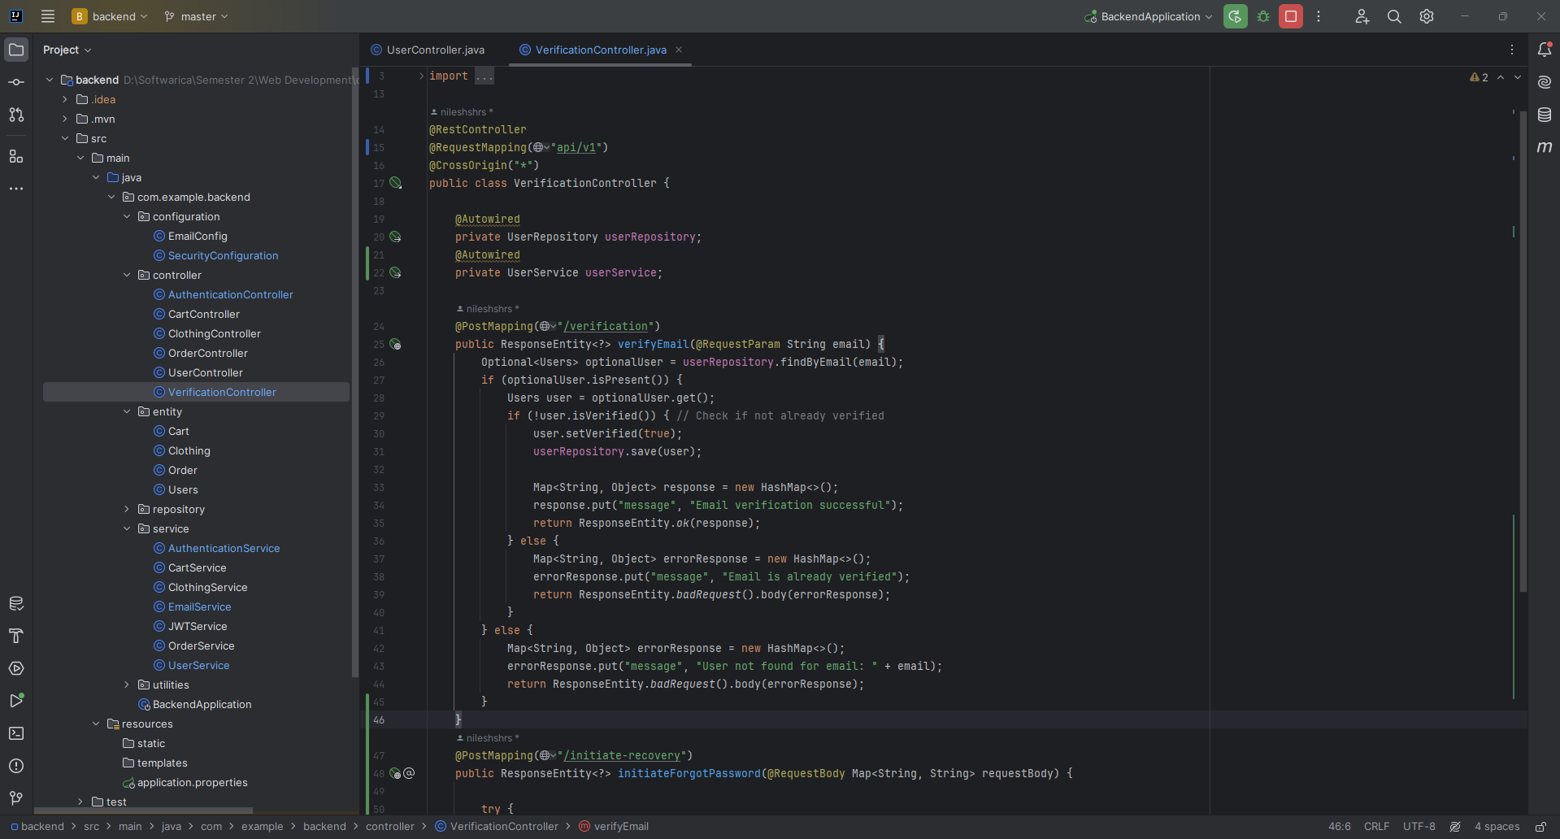

### Figure 30: Cart Entity

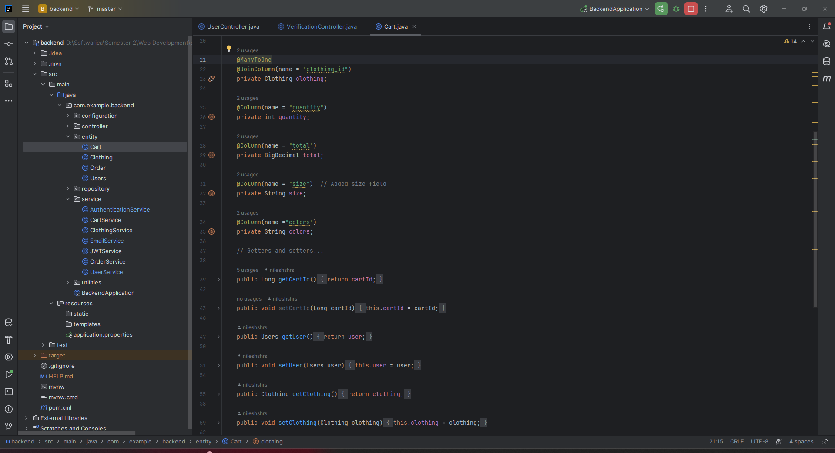

### Figure 31: Order Entity

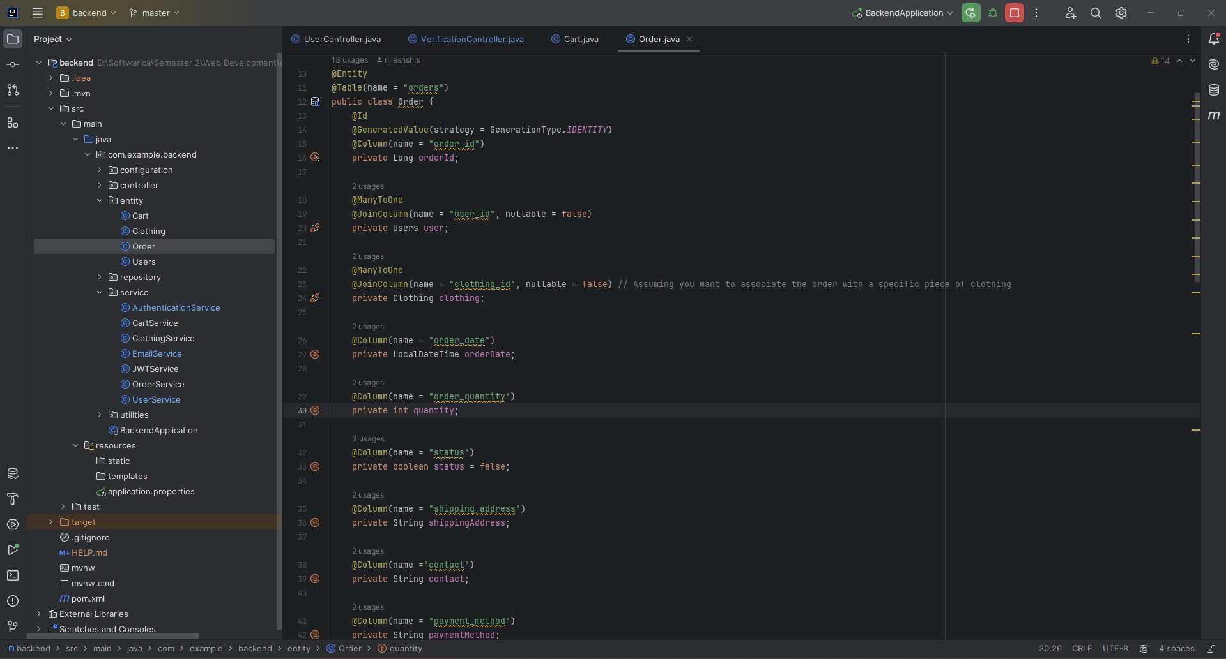

### Figure 32: Clothes Entity

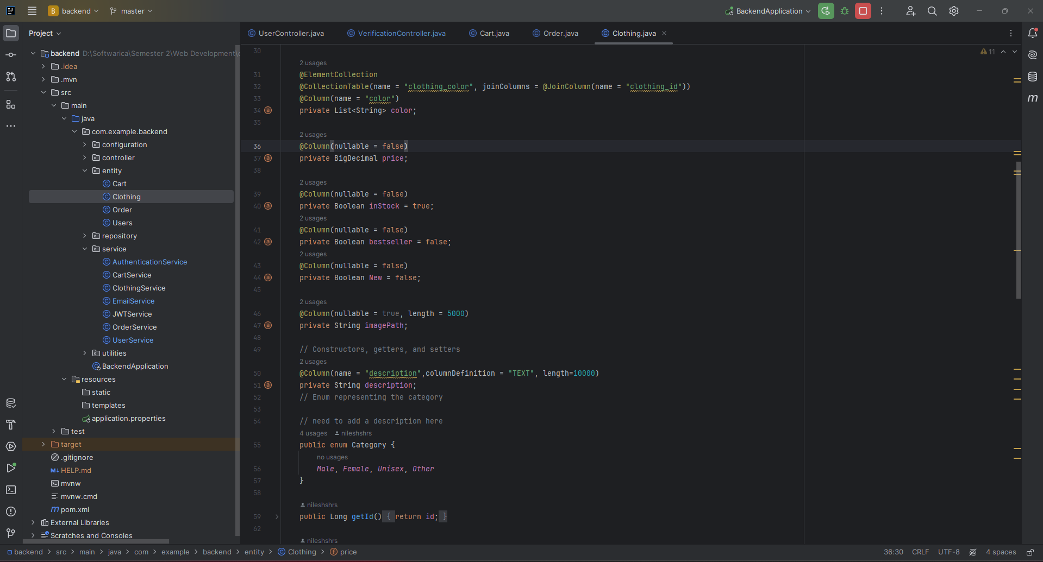

### Figure 33: User Entity

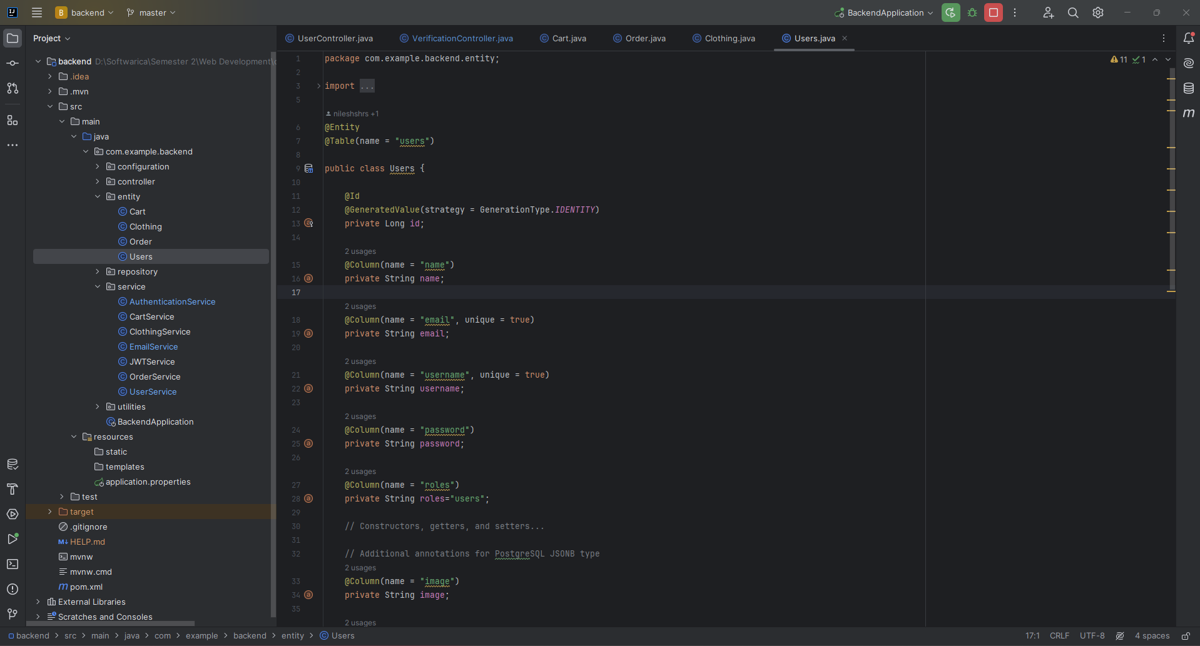

### Figure 34: Cart Repository

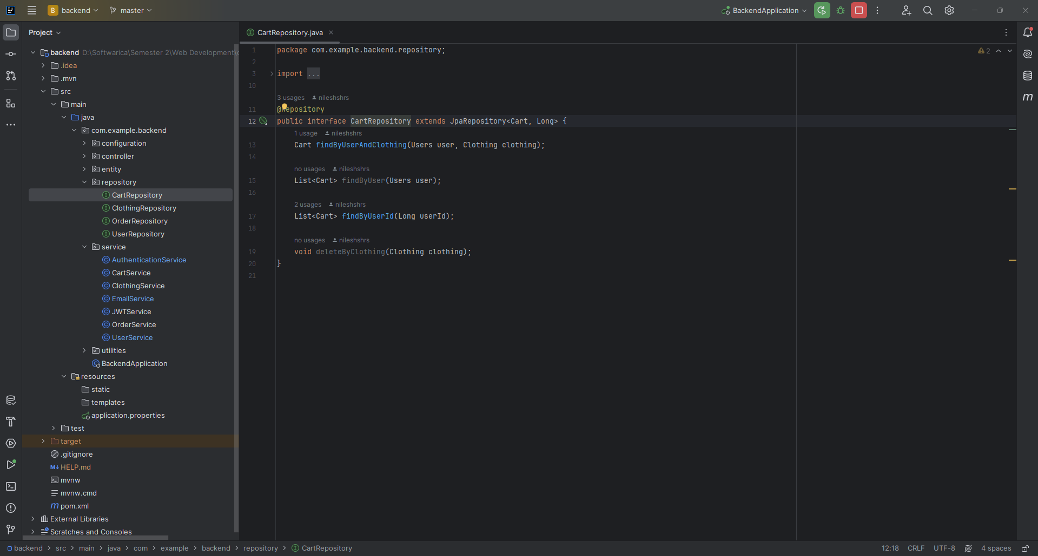

### Figure 35: Clothes Repository

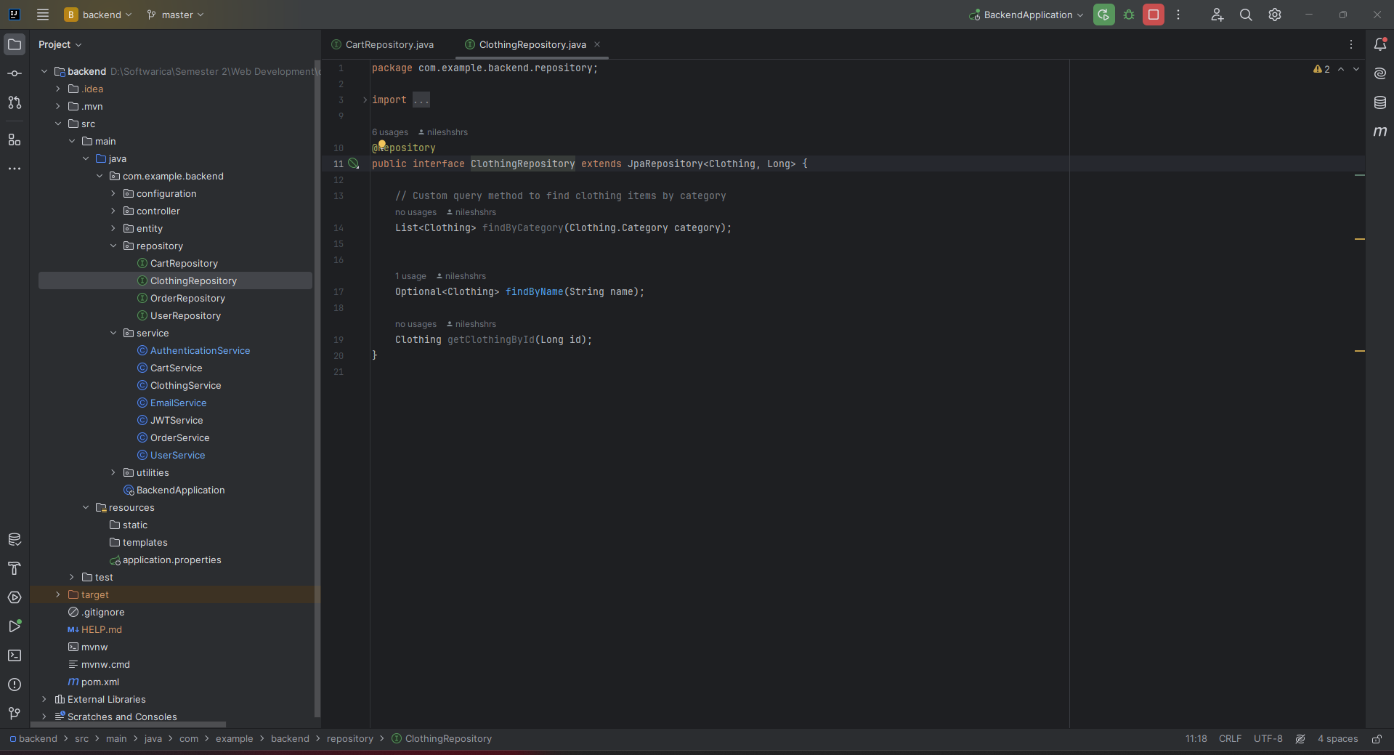

### Figure 36: Order Repository

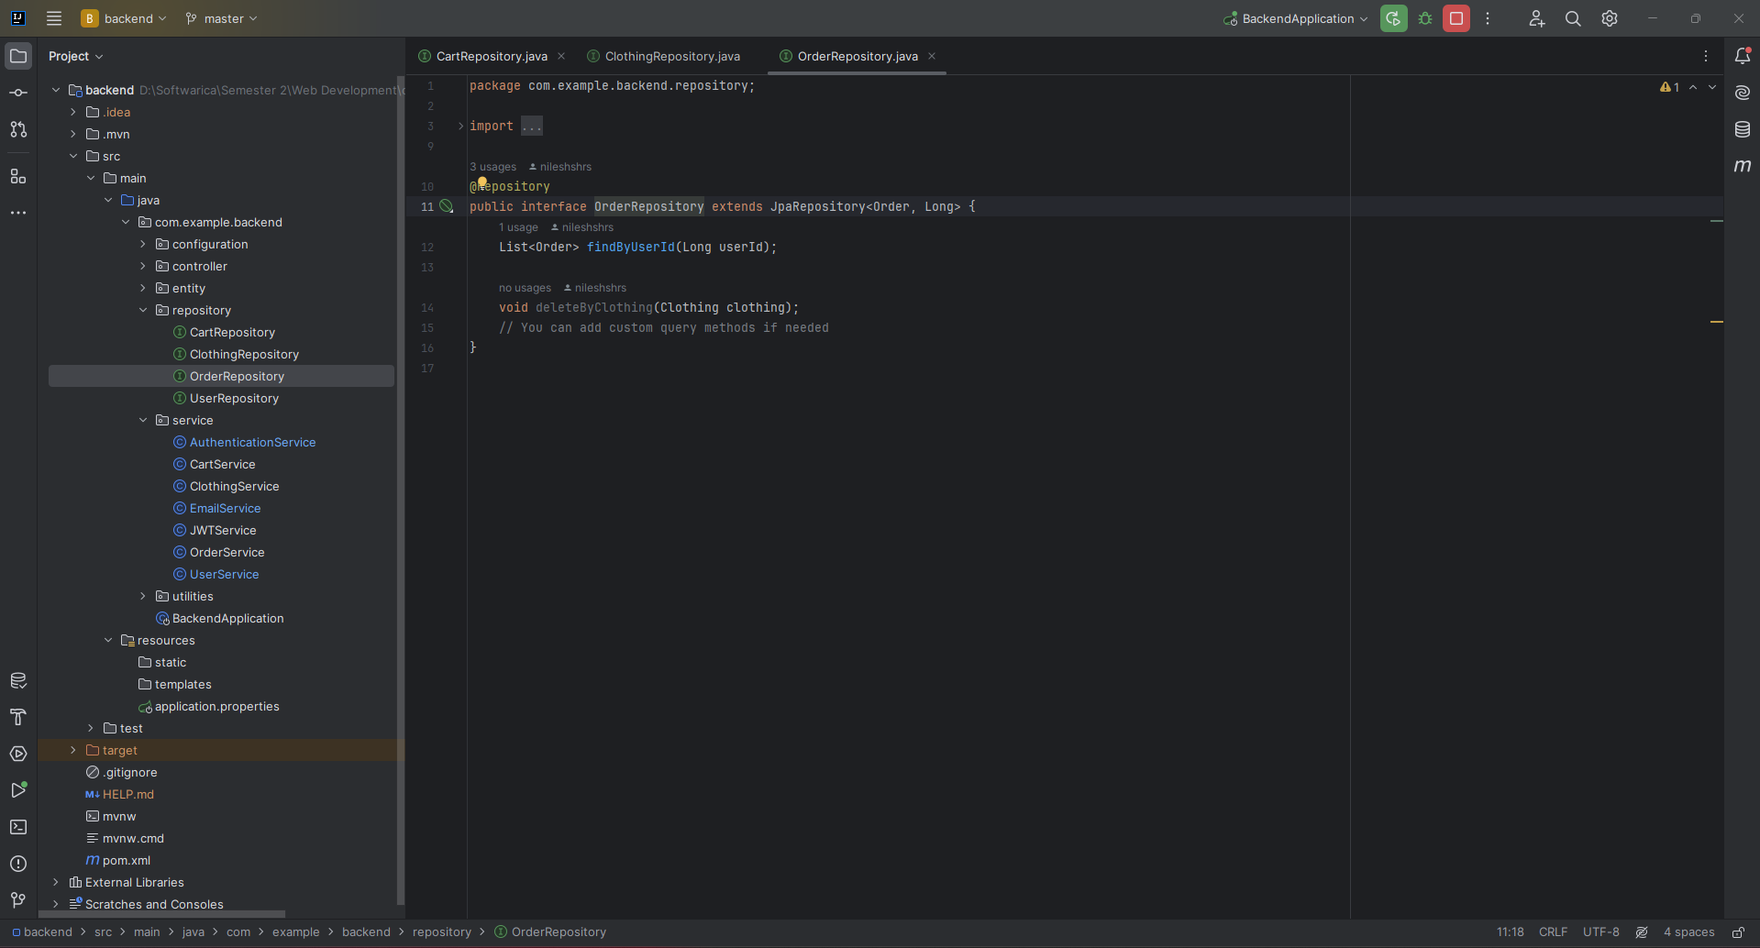

### Figure 37: User Repository

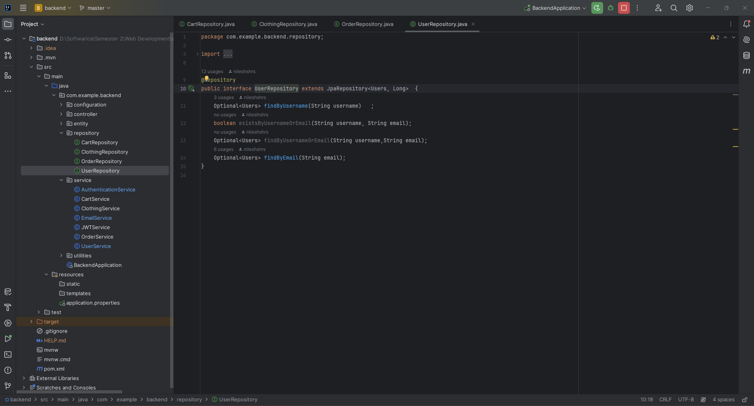

### Figure 38: Authentication Service

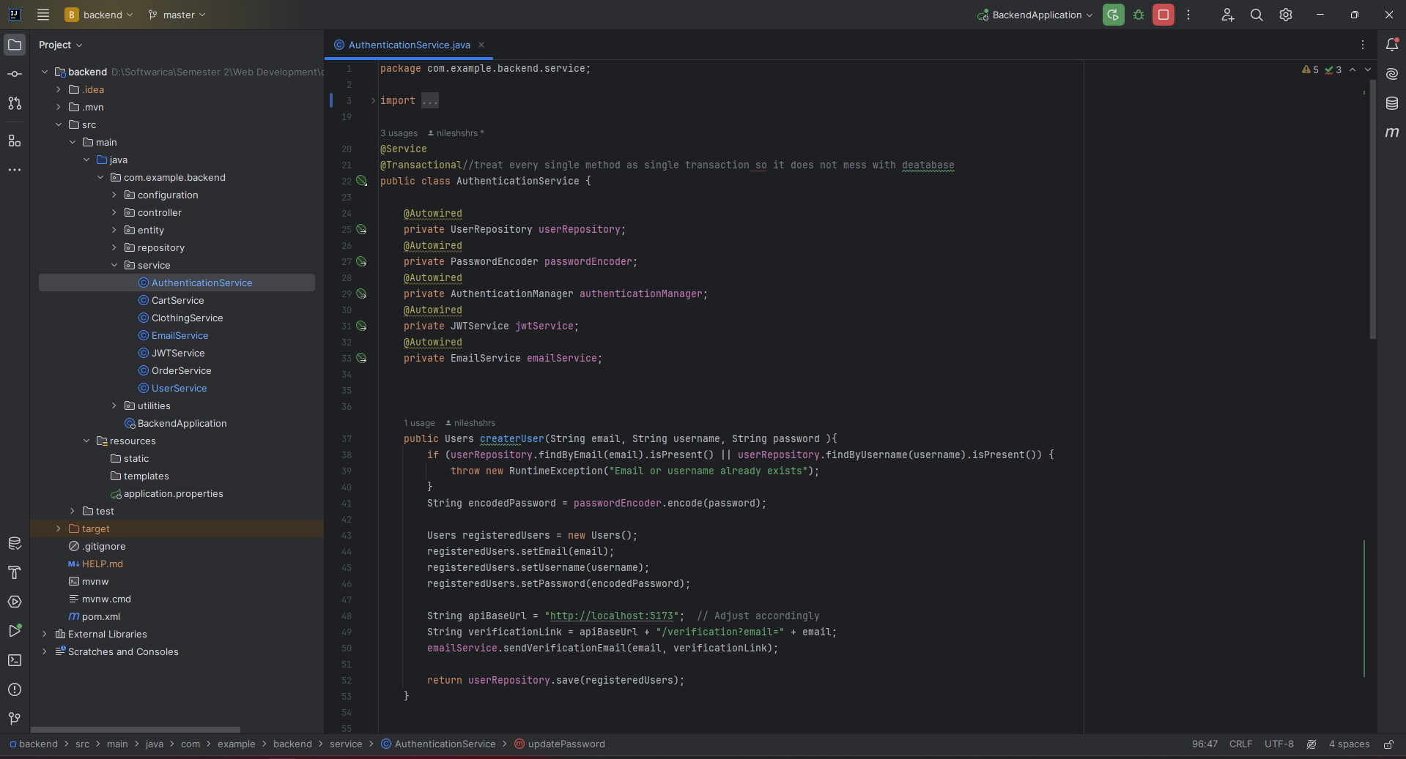

### Figure 39: Cart Service

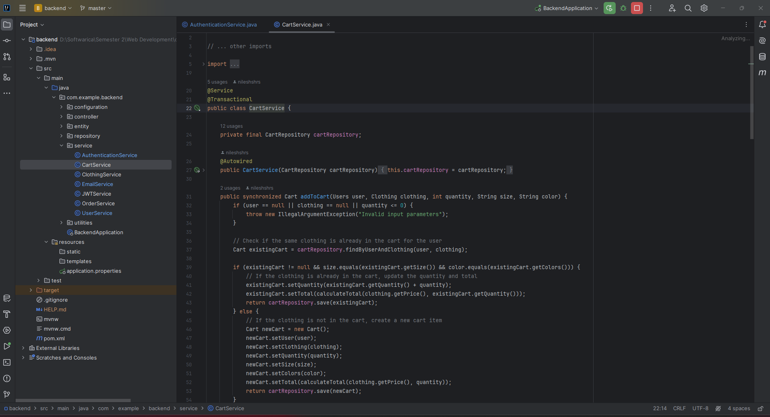

### Figure 40: Clothes Service

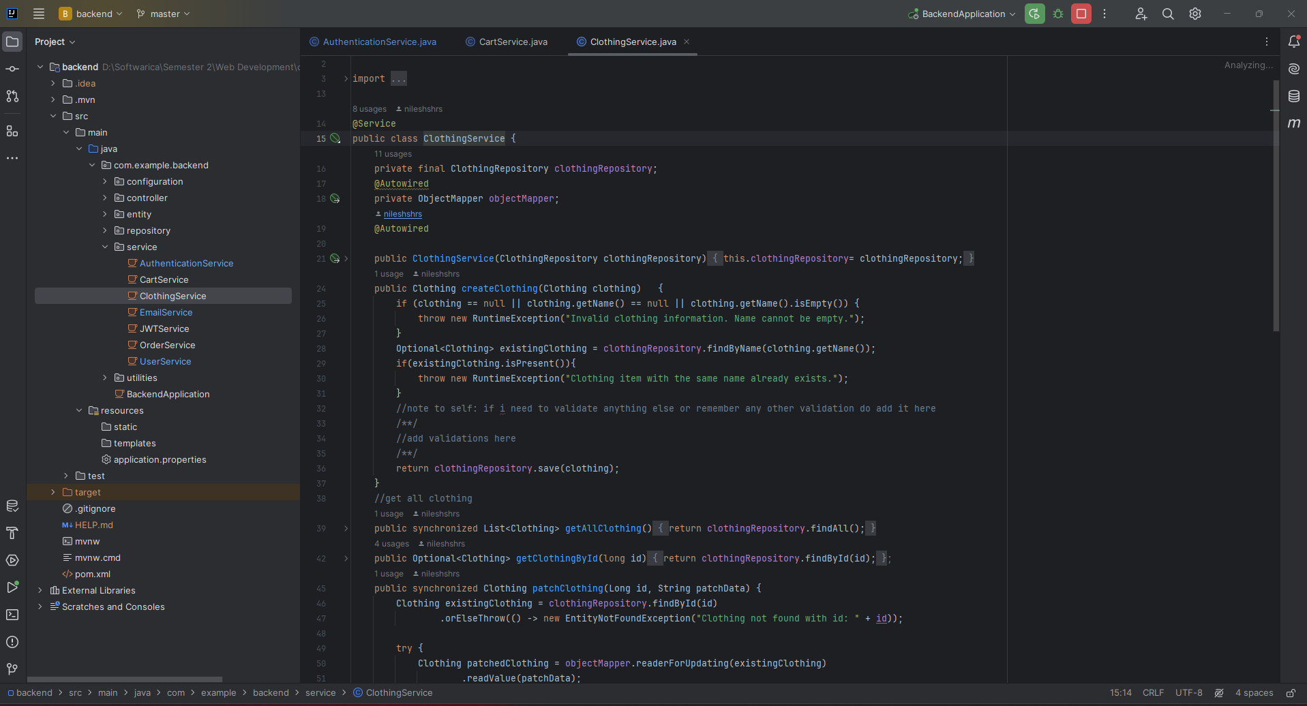

### Figure 41: Email Service

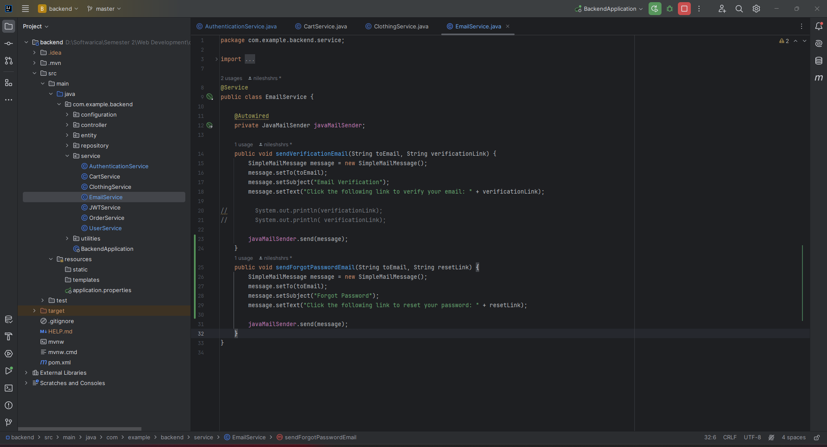

### Figure 42: JWT Service

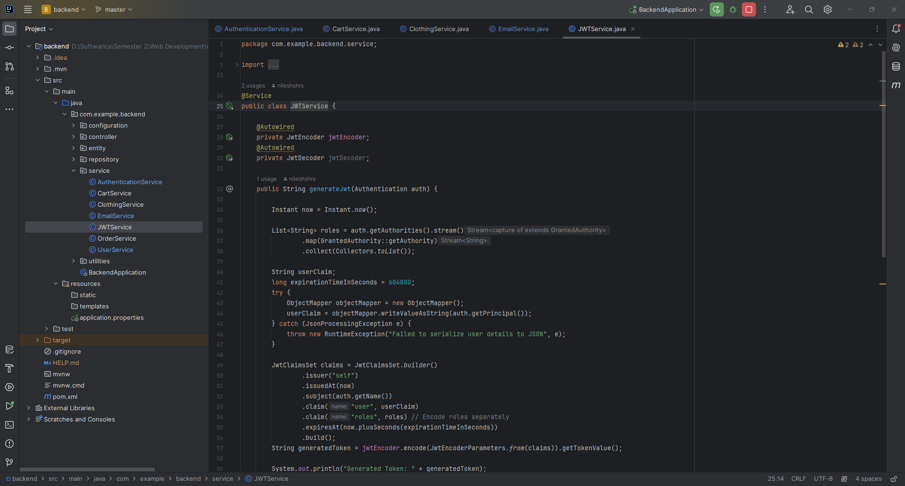

### Figure 43: Order Service

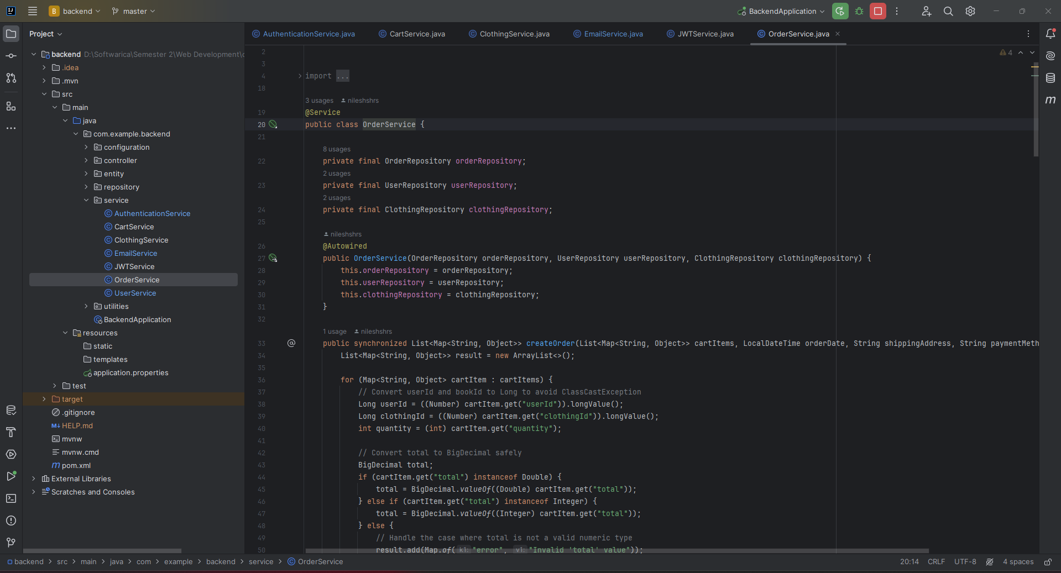

### Figure 44: User Service

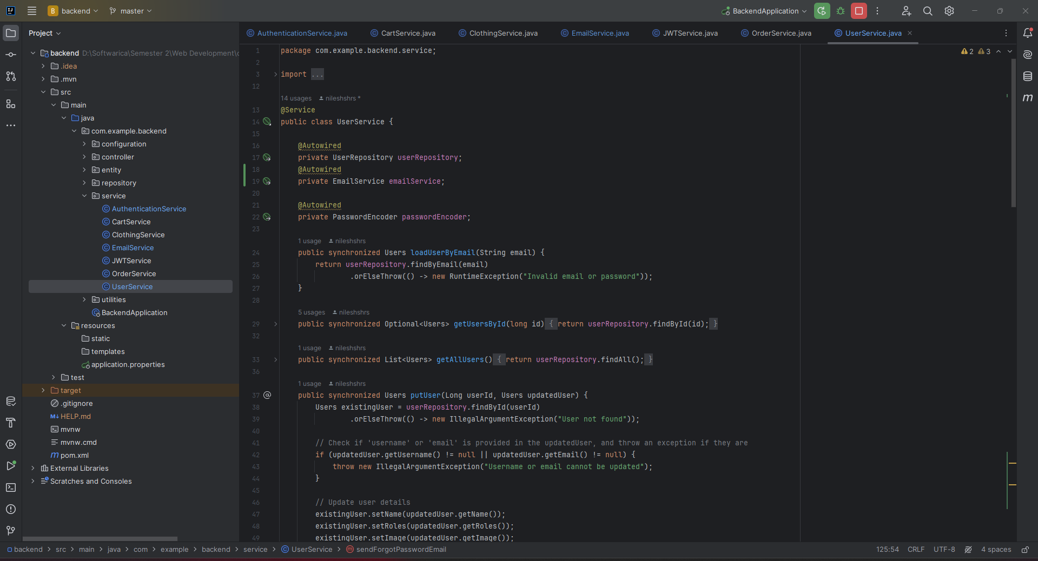

### Responsive Design

Responsive design was meticulously crafted for the Cuts Clothing website, ensuring a seamless and consistent user experience across a spectrum of devices. The project's dedication to cross-device optimization led to an in-depth exploration of layout design and styling elements, dynamically adjusting to diverse screen sizes (*Responsive Web Design: What It Is and How to Use It — Smashing Magazine*, 2011). The fusion of Tailwind CSS and custom styling with Sass extended the responsiveness, allowing for efficient and expressive styling through utility classes while leveraging Sass for modular and organized CSS.

The strategic adoption of a mobile-first approach defined the project's design philosophy. The website was intentionally crafted for mobile devices initially, reflecting a commitment to cater to the expanding mobile user base. As the design progressed, enhancements for larger screens were seamlessly integrated, striking a balance between simplicity and efficiency. Tailwind CSS played a pivotal role in this approach, providing a utility-first methodology that streamlined the design process and maintained a consistent and intuitive styling system.

The project also immersed itself in the intricacies of image optimization for various devices. Through the application of responsive design techniques, Tailwind CSS utility classes, and custom Sass, images were optimized for both visual appeal and performance. Techniques like lazy loading and responsive image rendering were tactfully implemented, contributing significantly to the overall optimization of the website's loading times and ensuring a delightful user experience.

### Figure 45: Responsive Home Page

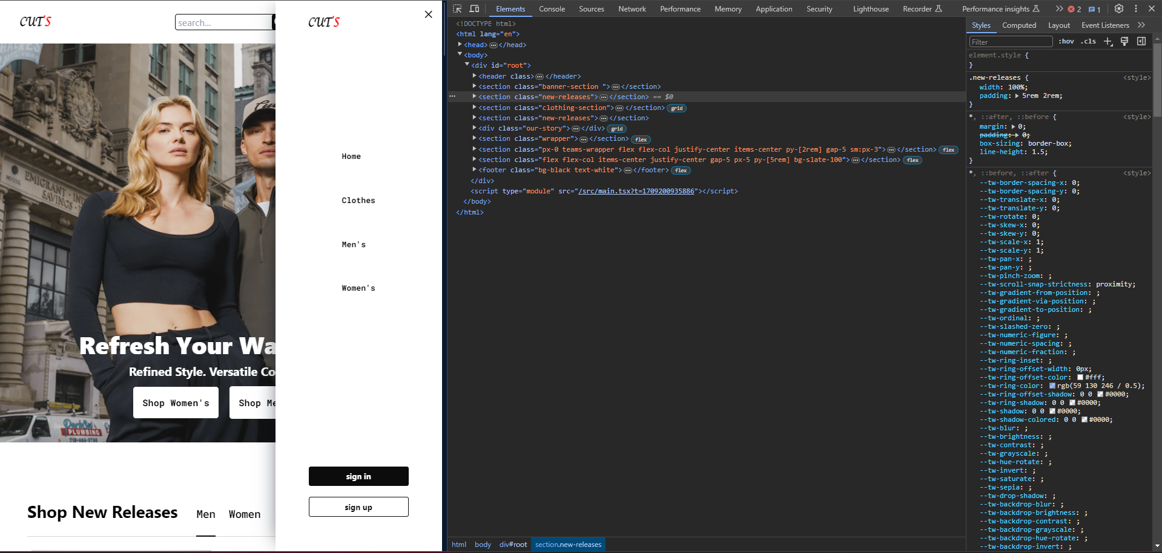

In summary, the Cuts Clothing project provided a comprehensive education in frontend development, responsive design principles, and backend development proficiency. From mastering Reacts’ component-based architecture and state management to implementing responsive design strategies and building a robust backend with Spring Boot, PostgreSQL, and Hibernate, the project enriched my skill set and positioned me to tackle diverse challenges in web application development.

# Testing

### Unit Testing approach:

Within the scope of unit testing for the Cuts Clothing backend, a systematic strategy will be implemented to evaluate the functionality of individual components in isolation. This process entails subjecting specific units, including Spring Boot services and database interactions, to comprehensive unit tests.

For Spring Boot services, the unit testing framework will predominantly involve JUnit, a widely-used testing library for Java classes. This choice aligns with the convention of ensuring that individual service methods are rigorously tested to verify their intended functionality. Mockito will complement the testing framework by facilitating the creation of mock objects, isolating dependencies for controlled testing environments.

Database interactions, a critical aspect of backend functionality, will undergo testing with a focus on Spring Data repositories. JUnit will be employed to validate the proper functioning of data-related operations within the service layer. This includes ensuring data integrity through thorough examination of database interactions, encompassing accurate data insertion, retrieval, and modification. The testing suite will also address the management of database transactions to guarantee seamless functionality.

By concentrating solely on the unit testing approach for the backend, this strategy ensures a meticulous evaluation of individual components such as Spring Boot services and their interactions with the database. This focused testing approach aims to validate the correctness and reliability of the backend components in isolation, contributing to the overall robustness of the Cuts Clothing backend system.

### Figure 46: Backend application Test

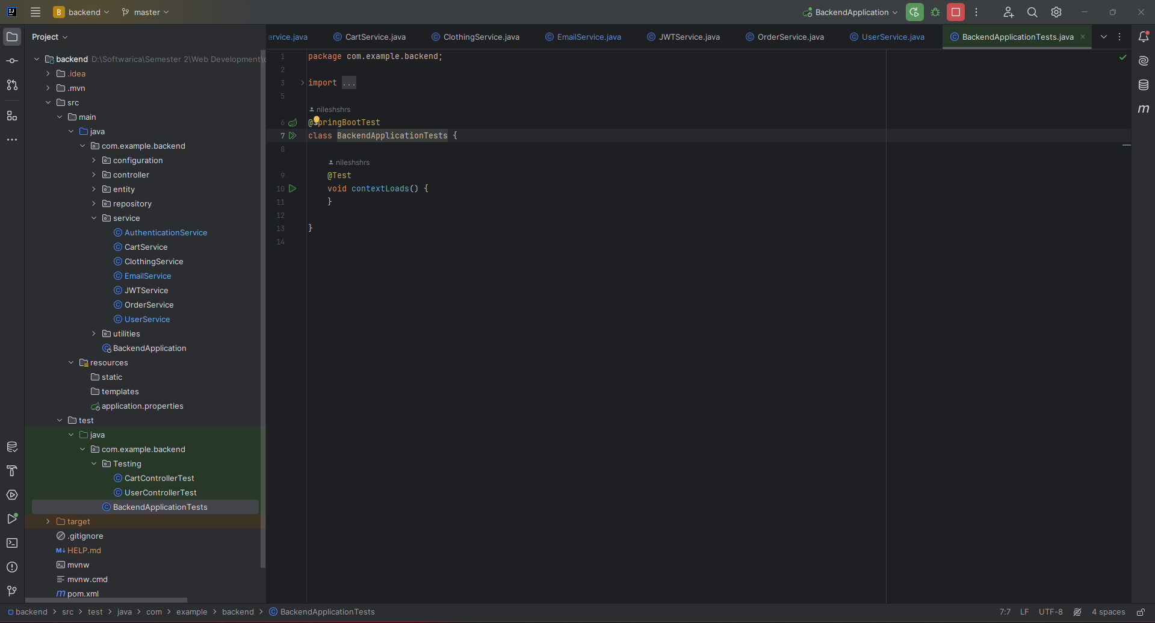

### Figure 47: Cart Controller Test

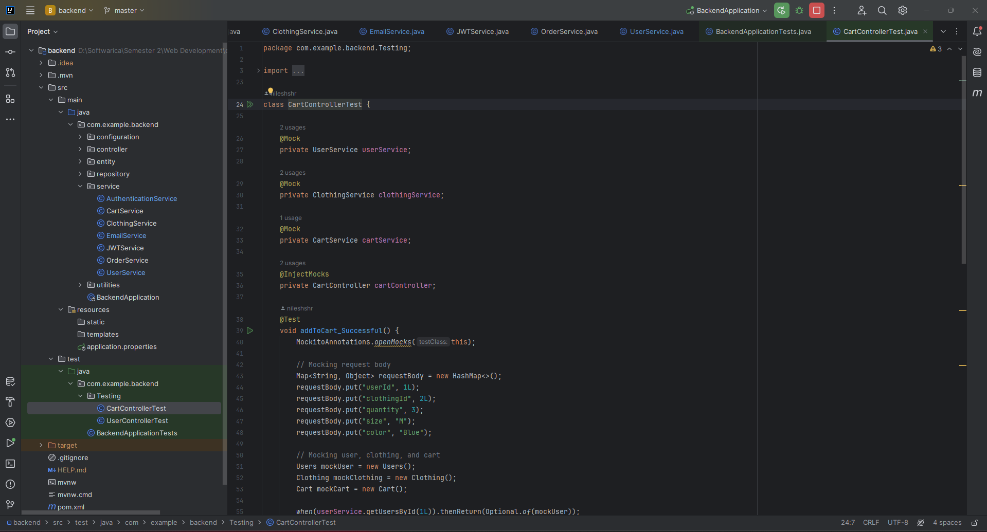

### Figure 48: User Controller Test

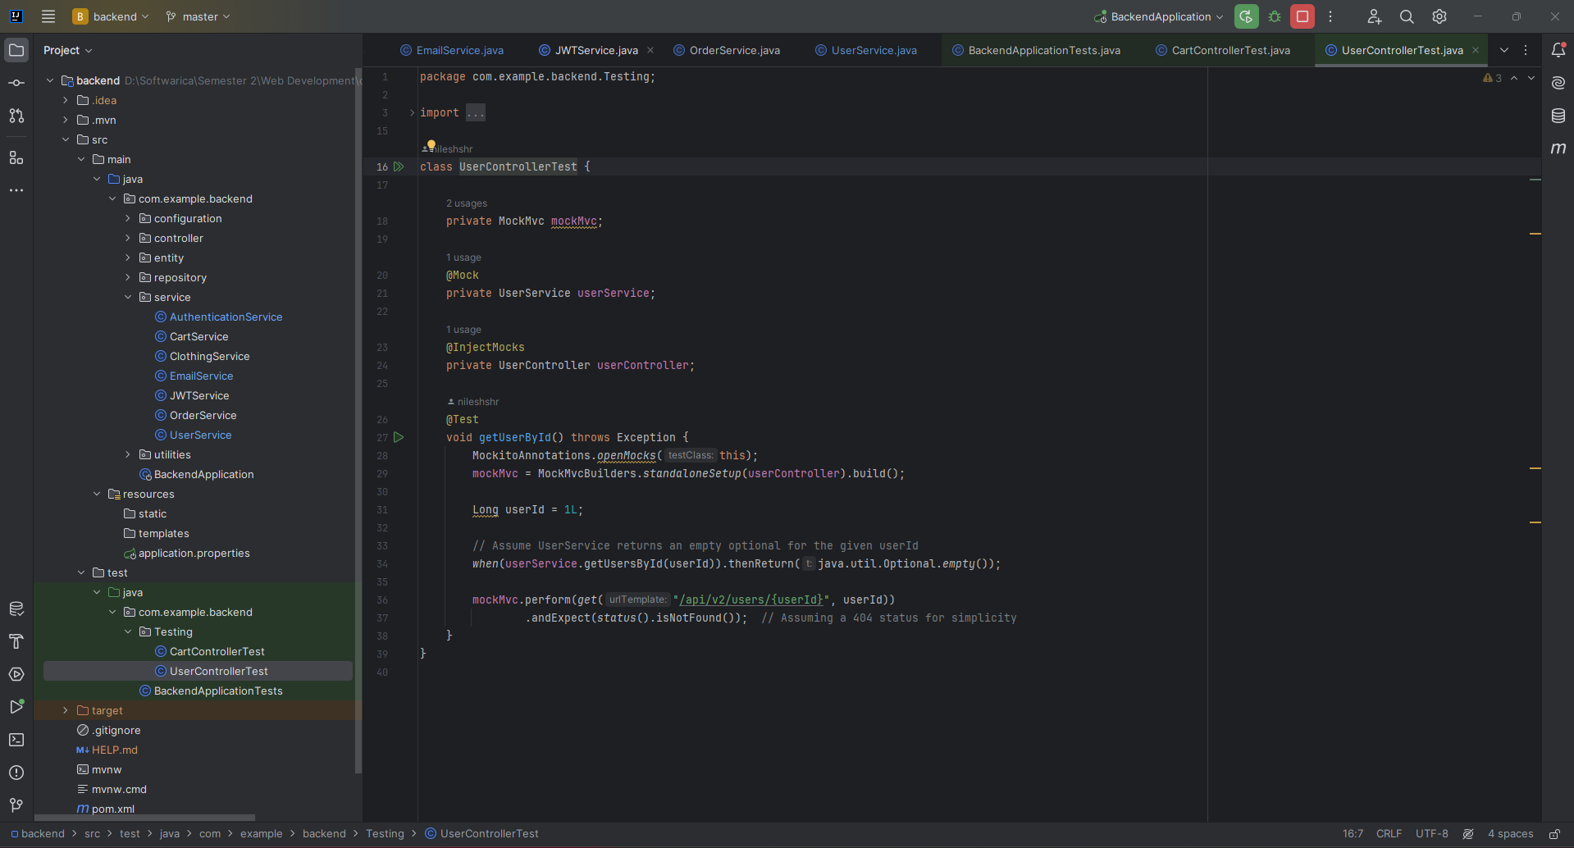

### Behavior Driven Development:

Behavior-Driven Development (BDD) takes a user-centric perspective, capturing the expected system behavior in a manner understandable to both technical and non-technical stakeholders. In the context of the Cuts Clothing project, this approach involves the creation of feature files and corresponding step definitions, fostering collaboration across development, testing, and non-technical teams.

Feature files will encapsulate user stories, employing the Gherkin syntax to articulate scenarios in a human-readable format (Szyrner, 2023). Step definitions, written in Java, will map to these scenarios, ensuring the alignment of the implemented functionality with the expectations outlined in the feature files. The integration of Cucumber with JUnit will facilitate the execution of these step definitions as part of the testing suite.

Execution of BDD scenarios will serve as end-to-end tests, validating the collaboration between various layers of the application. This holistic approach ensures that the implemented features align with user expectations, providing a comprehensive evaluation of the application's functionality and adherence to specified requirements.

# Conclusion

In conclusion, the Cuts Clothing website adeptly integrates contemporary technologies, notably employing React, Spring Boot, and PostgreSQL, thereby delineating a sophisticated milieu for online fashion retail. The platform's discerningly designed user interface and its robust backend collectively afford a dynamic arena for fashion aficionados, aligning seamlessly with the project's overarching objective of reshaping the exploration of sartorial expressions.

The project's stipulated objectives, encompassing the practical application of programming skills and the creation of a pertinent industry showcase, have been judiciously actualized. Paramount functional requirements, including streamlined user registration, effective login mechanisms, and comprehensive product catalog management, collectively augment the website's immersive and compelling user interface.

The conscientiously constructed entity relationship diagram and the implemented three-tier architecture underscore the project's commitment to scalability, reliability, and optimal operational efficiency. This methodical approach serves as a bedrock, ensuring a sturdy foundation for the website's functionalities and, consequently, contributes substantively to its overall efficacy.

In essence, the Cuts Clothing project serves as an exemplar of the adept integration of leading-edge technologies, furnishing a sophisticated digital haven for fashion enthusiasts and making a discernible impact in the dynamic sphere of online retail.

# References

Editor. (2023, December 30). Nonfunctional requirements in software engineering: Examples, types, best practices. *AltexSoft*. <https://www.altexsoft.com/blog/non-functional-requirements/>

CrowdStrike. (2023b, November 7). *What is Software Security? - CrowdStrike*. crowdstrike.com. <https://www.crowdstrike.com/cybersecurity-101/security-it-operations/software-security/>

Pfeil, M. (2010b, October 22). What is Data Persistence and Why Does it Matter? | Datastax. *DataStax*. <https://www.datastax.com/blog/what-persistence-and-why-does-it-matter>

*What is Three-Tier Architecture | IBM*. (n.d.). <https://www.ibm.com/topics/three-tier-architecture>

Abba, I. V. (2022, October 21). *What is an ORM – The Meaning of Object Relational Mapping Database Tools*. freeCodeCamp.org. <https://www.freecodecamp.org/news/what-is-an-orm-the-meaning-of-object-relational-mapping-database-tools/>

*Responsive web Design: What it is and how to use it — Smashing magazine*. (2011, January 12). Smashing Magazine. <https://www.smashingmagazine.com/2011/01/guidelines-for-responsive-web-design/>

Deshpande, C. (2023, October 5). *The best guide to know what is react*. Simplilearn.com. <https://www.simplilearn.com/tutorials/reactjs-tutorial/what-is-reactjs>

Kalam, N. (2023, April 9). Why Spring Boot is the Go-To Backend Framework: Top Features Explained. *Medium*. <https://enlear.academy/why-spring-boot-is-the-go-to-backend-framework-top-features-explained-9e83d17fe4f1>

Szyrner, T. (2023, August 22). *How to start writing Gherkin test scenarios?* <https://selleo.com/blog/how-to-start-writing-gherkin-test-scenarios>

Admin. (2022, September 30). *Difference between CSS and SCSS*. BYJUS. <https://byjus.com/gate/difference-between-css-and-scss/#:~:text=CSS%20is%20a%20styling%20language,SCSS%20in%20the%20Ruby%20language>.

# Appendix

### GitHub Link:

<https://github.com/nileshshrs/clothing-store>

### YouTube Link:

<https://www.youtube.com/watch?v=AvP07wNofgI>